|  |
| --- |
| Department of Agriculture, Land Reform and Rural Development– national geomatics managEment service |
| **CRVMP_0003_DEV_Functional**  **Requirements Specification**  **Spatial** |
| |  |  | | --- | --- | | **Author:** | Phila Dlamini, Adhir Nursayhe | | **Branch/Organisation:** | Data World | | **Document ID:** | CRVMP_0003_DEV_FunctionalRequirementsSpecification_Spatial | | **First Revision Date:** | 16/03/2020 | | **Current Version Date:** | 14/07/2020 | | **Revision:** | 1.0 | | **Version:** | 1.5 | |

Notice

Please note that this document may contain information which constitutes confidential or proprietary information of Data World or the Department of Agriculture, Land Reform and Rural Development. Any such information shall only be used, by the respective parties, for the sole purposes of complying with their obligations within this project and may not be disclosed, copied, reproduced, divulged, published, distributed or circulated in any manner whatsoever or be exploited or used for any commercial purposes whatsoever.

Approval

The signatories hereof, being duly authorized thereto, by their signatures hereto authorise the execution of the work detailed herein or confirm their acceptance of the contents hereof and authorise the implementation/adoption thereof for and on behalf of the parties represented by them.

|  |  |  |
| --- | --- | --- |
|  |  |  |
|  |  |  |
| Acting Chief Surveyor-General: Ms Rosalind Mdubeki  (Executive Project Sponsor) |  | Date |
|  |  |  |
|  |  |  |
| Director: Cadastral Spatial Information -  Mr. Sibusiso Dlamini |  | Date |

Contents

1. Configuration Management 7

1.1 Document Audience and Distribution 7

1.2 Version History 8

1.3 Acronyms and Descriptions 9

1.4 Terminology and Definitions 10

1.5 References 11

2. Purpose of the Document 11

3. Document Overview 12

4. Background and Rationale 13

5. Spatial Business Requirements 13

5.1 Scope 13

5.1.1 Inclusions 13

5.1.2 Exclusions 15

5.2 Assumptions 15

Table 1 : Output and Conversion Types 16

5.3 Module Interfaces Impacting on the Module 17

5.4 Legislation and Standards Impacting on Module 17

5.5 Notations 18

5.5.1 Process Flow Notation 18

5.5.2 Use Case Diagram Notation 19

5.6 Spatial Requirements Overview 20

5.7 The Spatial Viewer 21

6. Functional Requirement 1 - Spatial Viewer 22

6.1 Search Tool 22

6.1.1 Attribute Search Business Rules 23

6.1.2 Attribute Search Process Flow 24

6.1.3 Attribute Search Action Node Description 25

6.1.4 Attribute Search Use Case Diagram 27

6.1.5 Attribute Search Use Case Description 27

6.1.6 Search by Graphic Business Rules 30

6.1.7 Search by Graphic Process Flow 33

6.1.8 Search by Graphic Action Node Description 34

6.1.9 Search by Graphic Use Case Diagram 35

6.1.10 Search by Graphic Use Case Description 36

6.1.11 Street Address Search – Business Rules 38

6.2 Map Navigation Tools – Business Rules 39

6.3 Identify Tool Business Rules 41

6.4 Share View Tool Business Rules 43

6.5 Print and Export Tool Business Rules 44

6.5.1 Standard Map Print 44

6.5.2 Print in Projected Coordinate System 44

6.6 Bookmark Tool Business Rules 46

6.7 Layer Manager Tool Business Rules 46

6.8 Refresh Data Sources Tool Business Rules 47

6.9 Reset Map Tool Business Rules 47

6.10 Measure Tool Business Rules 47

6.11 Map Legend Tool Business Rules 47

6.12 Alpha Numeric Data Tool Business Rules 48

7. Functional Requirement 2 - Spatial Viewer UAM 49

8. Functional Requirement 3 - Spatial Viewer Information Management 50

8.1 Spatial Viewer Single Requests 50

8.1.1 Spatial Viewer Single Requests – Business Rules 50

8.1.2 Spatial Viewer Single Request Process Flow 52

8.1.3 Spatial Viewer Single Request Action Node Description 53

8.1.4 Spatial Viewer Single Request Use Case Diagram 56

8.1.5 Spatial Viewer Single Request Use Case Description 56

8.2 Spatial Viewer Bulk Requests 60

8.2.1 Spatial Viewer Bulk Requests - Business Rules 60

8.2.2 Spatial Viewer Bulk Requests – Process Flow 62

8.2.3 Spatial Viewer Bulk Requests – Action Node Description 63

8.2.4 Spatial Viewer Bulk Requests – Use Case Diagram 66

8.2.5 Spatial Viewer Bulk Requests – Use Case Description 66

8.3 Parametrised Viewer 70

8.3.1 Parametrised Viewer Business Rules 70

8.3.2 Parametrised Viewer Process Flow 73

8.3.3 Parametrised Viewer Action Node Description 74

8.4 Pre-packaged Data 75

8.4.1 Pre-packaged Data business rules 75

9. Map Configurations 76

10. Integration 81

11. Reports 83

11.1.1 Sample Statistical Report 84

12. System Administration Module 85

13. Annexures 85

13.1

Attributes of projected Coordinate system 85

13.2 PROJ.4 Definitions used in this project 85

13.3 Attributes and defining parameters of Projected Coordinate Reference Systems 86

Conceptual Data Model 93

For a detailed Spatial Data Model please refer to the Technical Document 93

13.4 Product and Services Mapping 94

13.5 Sample Map Template 95

Figures

Figure 1: Spatial Requirements Overview 19

Figure 2: The Spatial Viewer 20

Figure 3: Attribute Search Process Flow 23

Figure 4: Attribute Search Use Case Diagram 26

Figure 5: Sample Attribute Search Screen 29

Figure 6: Search by Graphic Process Flow 32

Figure 7: Search by Graphic Use Case Diagram 34

Figure 8 : Sample Search by Graphics 37

Figure 9: Sample Big Street Address Search Screen 38

Figure 10: Sample Map Navigation Tool Screen 40

Figure 11: Sample Identity Tool 41

Figure 12: Sample Print Screen 44

Figure 13: Spatial Viewer Single Request Process Flow 50

Figure 14: Spatial Viewer Single Request Use Case Diagram 54

Figure 15: Spatial Viewer Initiated Requests 58

Figure 16: Information Management Module Initiated Requests 59

Figure 17: Spatial Viewer Bulk Requests – Process Flow 60

Figure 18: Spatial Viewer Bulk Requests – Use Case Diagram 64

Figure 19: Search Screen and Search Results with Spatial Icon 69

Figure 20: The Screen Zoomed To 70

Figure 21: Parametrized Spatial Viewer Process Flow 71

Figure 22 : Sample Configuration Log in Screen 74

Figure 23: Sample Configuration Welcome Screen 75

Figure 24:Sample Configuration Data Menu Screen 75

Figure 25:Sample Configuration Add New Data Menu 76

Figure 26:Sample Configuration View Published Layer 76

Figure 27:Sample Configuration Layer Styles 77

Figure 28:Sample Configuration Add New Layer Styles 77

Figure 29:Sample Configuration Preview Layers in Data Menu 78

Tables

Table 1 : Output and Conversion Types 15

Table 2: Process Flow Notation 18

Table 3: Use Case Diagram Notation 18

Table 4 : Spatial Search Criteria 21

Table 5: Attribute Search Action Node Description 25

Table 6: Attribute Search Use Case Description 28

Table 7: Search by Graphic Action Node Description 34

Table 8: Search by Graphics Use Case Description 36

Table 9: User Functionalities and Access 47

Table 10: Spatial Viewer Single Request Action Node Description 53

Table 11: Spatial Viewer Single Request Use Case Description 57

Table 12 : Spatial Viewer Triggered Information Requests 58

Table 13: Information Management Module Triggered Requests 59

Table 14: Spatial Viewer Bulk Requests – Action Node Description 63

Table 15: Spatial Viewer Bulk Requests – Use Case Description 68

Table 16: Parametrised Viewer Action Node Description 72

Table 17: Integration Touch Points 79

# Configuration Management

## Document Audience and Distribution

| Name | Office | Capacity | E-Mail | Category  # Ref to note |
| --- | --- | --- | --- | --- |
| Rosalind Mdubeki | NGMS | Acting Chief Surveyor-General | Rosalind.Mdubeki@drdlr.gov.za | AP |
| Nondwe Monyake | NGMS | Surveyor-General KwaZulu-Natal | Nondwe.Monyake@drdlr.gov.za | I |
| Julian Williamson | NGMS | Surveyor-General Western Cape | Julian.Williamson@drdlr.gov.za | I |
| Chris Williams-Wynn | NGMS | Surveyor-General Eastern Cape | [Chris.WilliamsWynn@drdlr.gov.za](mailto:Chris.WilliamsWynn@drdlr.gov.za) | I |
| Victor Constable | NGMS | Surveyor-General Mpumalanga | Victor.Constable@drdlr.gov.za | RV |
| Elbe Janse van Rensburg | NGMS | Surveyor-General Gauteng | Elbe.JansevanRensburg@drdlr.gov.za | I |
| Sibusiso Dlamini | NGMS | Director: CSI | [Sibusiso.Dlamini@drdlr.gov.za](mailto:Sibusiso.Dlamini@drdlr.gov.za) | AP |
| Inban Moodley | OCIO | Chief Information Officer | Inban.Moodley@drdlr.gov.za | RV |
| Roy Naidoo | OCIO | Director: Service Management | Roy.Naidoo@drdlr.gov.za | I |
| Phuti Lekgau | OCIO | Director: Solution Development | Phuti.Lekgau@drdlr.gov.za | I |
| Boitumelo Sephoti | Internal Audit | Director: Internal Audit | [Boitumelo.Sephoti@drdlr.gov.za](mailto:Boitumelo.Sephoti@drdlr.gov.za) | RV |
| Gole Netshitshivhe | NGMS | Director Technical Services: SG-LMP | gole.netshishivhe@drdlr.gov.za | RV |
| Shadrack Rambau | NGMS | Business Representative | Shadrack.rambau@drdlr.gov.za | RV |
| Piet Swart | NGMS | Director Technical Services: SG-WC | [Pieter.Swart@drdlr.gov.za](mailto:Pieter.Swart@drdlr.gov.za) | RV |
| Elias Sithole | NGMS | Deputy Director: Quality Assurance | Elias.Sithole@drdlr.gov.za | RV |
| Babalwa Lujabe | OCIO | Project Manager | [Babalwa.Lujabe@drdlr.gov.za](mailto:Babalwa.Lujabe@drdlr.gov.za) | RV, C |
| Nonceba Jali | NGMS | Director Technical Services: SG-KZN | Nonceba.Jali@drdlr.gov.za | RV |
| Elias Shongwe | NGMS | Acting Director Technical Services: SG-NW | [Elias.shongwe@drdlr.gov.za](mailto:Elias.shongwe@drdlr.gov.za) | I |
| Prince Mashele | NGMS | Spatial Data Manager SG-NW | Prince.mashele@drdlr.gov.za | RV |
| Thembela Gazi | NGMS | Director Technical Services: SG-EC | [Thembela.Gazi@drdlr.gov.za](mailto:Thembela.Gazi@drdlr.gov.za) | RV |
| Bongani Mtshali | NGMS | Director – Technical Services SG- BFN | Bongani.Mtshali@drdlr.gov.za | RV |
| Nokuphila Mnyandu | NGMS | Director Technical Services: SG-MPU | Nokuphila.Mnyandu@drdlr.gov.za | I |
| Fani Motimone | NGMS | Control Survey Technician: SG: GP | Fani.motimone@drdlr.gov.za | RV |
| Wonder Modipa | NGMS | Director Technical Services: SG-GP | Wonder.Modipa@drdlr.gov.za | RV |
| Adhir Nursayhe | Data World | Project Manager | [adhir@dataworld.co.za](mailto:adhir@dataworld.co.za) | RV, C |
| Phila Dlamini | Data World | Senior Business Analyst | phila@dataworld.co.za | W |
| Boipelo Gaanakgomo | Data World | Business Analyst | [Boipelo@dataworld.co.za](mailto:Boipelo@dataworld.co.za) | W |
| Krishna Allam | Data World | Solution Architect | [krishna@dataworld.co.za](mailto:krishna@dataworld.co.za) | C |
| Rajesh Nooka | Data World | Business Development Manager | rajesh@dataworld.co.za | RV, C |

**#NOTE**

Categories of level of responsibility as determined below:

|  |  |  |
| --- | --- | --- |
| W | Document Author | Author of the document |
| RV | Review | Reviewer of the document (Could form one of the signatories) |
| C | Must be consulted | Contributes content |
| I | Must be informed | Person whom this document needs to be distributed to |
| RC | Recommender | Recommends approval of the document (One of the signatories) |
| AP | Approver | Approves document (One of the signatories) |

## Version History

|  |  |  |  |
| --- | --- | --- | --- |
| Date | Author | Version | Changes made |
| 16/03/2020 | Rajesh Nooka | 1.0 | First Release |
| 15/05/2020 | Phila Dlamini and Adhir Nursayhe | 1.1 | Updated with feedback from the following provinces:   1. Kwa Zulu Natal 2. Eastern Cape 3. Gauteng 4. NGI 5. Free State   (the detailed feedback and resolutions are in the feedback document CRVMP_0003_DEV_FRS_REVIEW_FEEDBACK 15052020) |
| 25/05/2020 | Phila Dlamini | 1.2 | Updated with feedback from Sibusiso Dlamini  (The detailed feedback and resolutions are in the feedback document CRVMP_0003_DEV_FRS_REVIEW_FEEDBACK _SP_25052020) |
| 26/06/2020 | Phila Dlamini | 1.3 | Updated with feedback from the following provinces:   1. Kwa Zulu Natal 2. Free State 3. Gauteng 4. Eastern Cape   (The detailed feedback and resolutions are in the feedback document CRVMP_0003_DEV_FRS_REVIEW_FEEDBACK _SP_26062020) |
| 07/07/2020 | Phila Dlamini | 1.4 | Updated with feedback from the following provinces:   1. Kwa Zulu Natal 2. Gauteng   (The detailed feedback and resolutions are in the feedback document CRVMP_0003_DEV_FRS_REVIEW_FEEDBACK _SP_08072020) |
| 08/08/2020 | Phila Dlamini | 1.5 | Updated with feedback from Mice Caister and NGI  (The detailed feedback and resolutions are in the feedback document CRVMP_0003_DEV_FRS_REVIEW_FEEDBACK _SP_08082020) |

## Acronyms and Descriptions

| **Abbreviation** | **Description** |
| --- | --- |
| **BRS** | Business Requirements Specification |
| **CIS** | Cadastral Information System |
| **CRE** | Certificate of Remaining Extent |
| **CSF** | Critical Success Factor |
| **CSG** | Chief Surveyor General |
| **CSV** | Comma-separated values |
| **DALRRD** | Department of Agriculture, Land Reform and Rural Development |
| **DBF** | Data Base File |
| **DSG** | Deputy Surveyor General |
| **DXF** | Drawing exchange Format |
| **EPSG** | European Petroleum Survey Group |
| **FRS** | Functional Requirements Specification |
| **FTP** | File Transfer Protocol |
| **GIS** | Geographic Information System |
| **GUI** | Graphical User Interface |
| **ISO** | International Organization for Standardization |
| **JPEG** | Joint Photographic Experts Group |
| **KML** | Keyhole Mark-up Language |
| **LPI** | Land Parcel Indicator |
| **MIOS** | Minimum Interoperability Standards |
| **Munsys** | A third-party system used by the Department |
| **NGI** | National Geo-spatial Information |
| **NGMS** | National Geomatics Management Service |
| **PCRS** | projected coordinate reference systems |
| **PDF** | Portable Document Format |
| **PNG** | Portable Network Graphics |
| **POPI** | Protection of Personal Information Act |
| **SG** | Surveyor General |
| **SMS** | Short Messaging Service |
| **WGS** | World Geodetic System |
| **WMS** | Web Map Service |

## Terminology and Definitions

|  |  |
| --- | --- |
| **Term** | **Definition** |
| **Bulk Request** | A Request for data where the configurable threshold for automated data provision is surpassed, currently set as 5 MB or 5 items from the GIS Viewer As well as other services where human intervention is required |
| **Erf** | An urban land parcel (This piece of land may be registered in a deed’s registry as an erf, lot, plot or stand.) |
| **Farm** | Rural Land parcel/ A piece of land registered in a deed’s registry as a farm and generally (but not exclusively) representing land used for agricultural purposes |
| **GeoServer** | GeoServer is an open source server for sharing geospatial data.  Designed for interoperability, it publishes data from any major spatial data source using open standards. |
| **Inbox** | Refers to the system inbox task list |
| **Land Parcel** | Unit of land in the form of a polygon delineated according to land ownership or land use. And includes real rights in land. |
| **LO** | The general name of the South African Projected Coordinate Reference System (SAPCRS). The SAPCRS uses the Gauss Conformal Projection, which is a transverse Mercator projection, and has two degrees wide zones, centred on the odd numbered meridians. Its coordinates are westings (y), measured from the central meridians, positive westwards, and southings (x), measured from the equator, positive southwards. Coordinates published prior to 1 January 1999 were referenced to the Cape Datum. Coordinates published after 1 January 1999 are referenced to the Hartebeesthoek94 Datum. |
| **Coordinate System** | A coordinate system is a reference system used to represent the locations of geographic features, imagery, and observations, such as Global Positioning System (GPS) locations, within a common geographic framework |
| **Parametrised Viewer** | The integrated and search result contextualized Spatial Viewer which will be accessible from the Information Provisioning Module’s search results grid. |
| **Portion** | Part or portion or subdivision of a parcel |
| **Projected coordinate system** | Mathematical transformation that take spherical coordinates (latitude and longitude) and transform them to an XY (planar) coordinate system. This enables you to create a map that accurately shows distances, areas, or directions |
| **Single Request** | A Request for data where the configurable threshold for automated data provision is not surpassed, currently set as 5 MB or 5 items from the GIS Viewer |
| **Shapefile** | A geospatial vector [data format for geographic information system (GIS) software](https://en.wikipedia.org/wiki/GIS_file_formats). It is developed and regulated by [Esri](https://en.wikipedia.org/wiki/Esri) as a mostly [open specification](https://en.wikipedia.org/wiki/Open_standard) for data interoperability among Esri and other [GIS software products](https://en.wikipedia.org/wiki/Geographic_information_system). The shapefile format can spatially describe [vector](https://en.wikipedia.org/wiki/Vector_graphics) features: [points](https://en.wikipedia.org/wiki/Point_(geometry)), [lines](https://en.wikipedia.org/wiki/Polyline), and [polygons](https://en.wikipedia.org/wiki/Polygons), representing, for example, [water wells](https://en.wikipedia.org/wiki/Water_well), [rivers](https://en.wikipedia.org/wiki/River), and [lakes](https://en.wikipedia.org/wiki/Lake). Each item usually has [attributes](https://en.wikipedia.org/wiki/Attribute_(computing)) that describe it, |
| **SG Number** | Surveyor- General Document Number |
| **SMS Gateway** | Short Message Service or Multimedia Messaging Service transmissions to or from a telecommunications network. |
| **Spatial Viewer** | The Geographical Information System (GIS) spatial data viewer which is developed as part of the CIS Revamp Project |
| **WMS** | provides a standard interface for requesting a geospatial map image. The benefit of this is that WMS clients can request images from multiple WMS servers, and then combine them into a single view for the user. The standard guarantees that these images can all be overlaid on one another as they actually would be in reality. Numerous servers and clients support WMS. |

## References

| **Document Name** | **Document Description** | **Author** | **Version/ID** | **Status** |
| --- | --- | --- | --- | --- |
| Business Case for Cadastral Information System Upgrade | Information System Upgrade | Sibongile Masungini | 0.3 | Final |
| CIS Revamp Terms of Reference  Ref:5-2-2-1 RDLR-0010 (2016/2017) | Terms of Reference for the appointment of a Service Provider for the provision of a Cadastral Information System Revamp service for a period of 5 years renewal after successful implementation of every milestone. | Phindi Nkosi | 1.10 | Final |
| Vision and Scope Document for CIS Revamp Project | Vision and Scope Document for CIS Revamp Project | Phindi Nkosi | 2.0 | Final |
| CRVMP_0004_DDP_Business Requirements Specification_07012019_V1.2_PD | Business Requirements Specification | Phila Dlamini | 1.2 | Final |
| CRVMP_0003_DEV_Functional Requirements Specification_23052019_V1.3_PD | Functional Requirements Specifications | Phila Dlamini & Boipelo Gaanakgomo | 1.3 | Final |
| CRVMP_DEV_0001_Functional Requirement Specification _Web Portal_V1.3_23052019_PD | Functional Requirements Specifications | Phila Dlamini | 1.3 | Final |
| CRVMP_0002_Dev_Functional Requirements Specification User Access Management–v1.3_PD_23052019 | Functional Requirements Specifications | Phila Dlamini | 1.3 | Final |

# Purpose of the Document

The purpose of the CIS Revamp Functional Requirements Specification is to define the business processes that are involved in the CIS Revamp Project, The Functional Requirements Specification (FRS) will be used to write the software to manage the revamped CIS. This document details the spatial requirements.

# Document Overview

This document has the sections as stated below;

1. **Purpose of Document** – This section outlines why the FRS is written;
2. **Background and Rationale** - This section sets the scene towards the inception of the CIS revamp project; it further justifies the reasoning behind executing the project
3. **Business Requirements –** This section outlines the business need that is being addressed by the document
4. **Inclusions –** This section specifies what will be delivered as part of this business need or module. The section sets the expectations for delivery for the envisaged module
5. **Exclusions –** This section categorically states what items will not be part of the delivery of this module or even items that for the delivery on this module are segregated
6. **Assumptions –** This section sets out the norms and expectations for the delivery of the envisaged
7. **Module Interfaces impacting on the module –** This section identifies what other module interfaces are dependent on this module. It can also identify other modules that this module feeds into
8. **Legislation and Standards Impacting on Module** – This section lists the regulations and ideals that the module hinges on.
9. **Notation**: This section describes the notation used in to describe the business processes;
10. **Spatial Requirements Overview –** This section describes an engineering diagram that defines the boundary between the module and its environment, showing the entities that interact with it. This diagramis a high-level view of a system.
11. **Process Flows –** This section is a graphical representation of the general flow of work and the relationship between major and minor processes of work. It further shows the decision points and some artefacts generated within the Information Management Module.
12. **Action Node Description –** This section further decomposes the process flows and describes in a narrative way what happens in each step/node of the process flow
13. **Business Rules –** This section depicts all the rules that govern the operation of each process flow within a module.
14. **Use Case Diagrams –** This section describes in a diagrammatic fashion the interaction between the actor on the system, their actions, and the inheritances of the actors in the process
15. **Reports –** This section shows what management information can be generated from the system in terms of statistics.
16. **System Administration –** This section shows what the system administrator can do to upkeep the CIS
17. **Map Configurations –** This section shows what aspects of the spatial viewer can be configured on the GeoServer with some examples of steps and screenshots.
18. **Integration –** This section shows the touch points for sending services payload structures and data between components.
19. **Annexures -** This section shows some artefacts that will be taken into consideration when developing the spatial module.

# Background and Rationale

The National Geomatics Management Service (NGMS) is a branch in the Department of Rural Development and Land Reform (DRDLR) whose primary objective is to provide efficient cadastral survey management services, to provide cadastral survey information services in support of land delivery and orderly land development.

The objectives of NGMS is to regulate the survey of land in the Republic of South Africa; and to provide for matters connected therewith by means of approval, maintenance and archiving of Cadastral Survey documents submitted by Land Surveyors; supplying cadastral information and facilitating the regulation of cadastral surveys in order to support land and economic development with special emphasis on Land Tenure Reform.

The Branch is mandated to perform its functions through the Land Survey Act, 1997 (Act No. 8 of 1997). This branch is responsible for the following:

* Regulation of Surveyor-General's offices;
* Examining and approving all surveys for the registration of land and real rights;
* Maintaining cadastral documents;
* Archiving all cadastral surveys;
* Compiling, maintaining, and revising maps of property boundaries;
* Providing cadastral advisory and spatial information services.

To fulfil the above mandate, the branch uses a Cadastral Information System (CIS). However, this current system is antiquated due to technology platform limitations; lack of source code, maintenance issues etc., and needs overhauling. Considering the challenges, the CIS Revamp project is initiated by NGMS.

# Spatial Business Requirements



## Scope

### Inclusions

The following aspects have been included in the business requirements for the Spatial Module with regards to Information Provisioning;

1. Development of a **Spatial Viewer** that will be accessed by registered and unregistered user through the Web Portal. The user access shall be controlled via the User Access Management Module.
2. Development of a **Spatial Viewer** with **Search Tools**;(the detail relating to search tools will be defined in the business rules section of the document.
   1. Attribute Search
   2. Search by Graphics
   3. Search by Street Address
3. Development of a Spatial Viewer with **Map Navigation Tools**.
4. Provision of an **Identify Tool** which will have the following
5. Standard Identify Function
6. Get More Attributes Function (envisaged attributes)
7. Attribute Table related to the identify function
8. Attribute data related to the attribute table
9. Development of a **Share View Tool**.
10. Implementation of a **Print and Export Tool** which will have the following:
    1. Print to scale
    2. Export
    3. Print in Projected Coordinate System Tool
11. Implementation of a **Bookmark Tool.**
12. Developmentof the **Refresh Data Sources Tool**
13. Development of a **Reset Map Tool**
14. Development of a **Measure Tool**
15. Development of a **Layer Manager** Tool
16. Development of a **Map Legend** Tool
17. Development of an Alpha Numeric **Data Extraction Tool**
18. Integration with the **User Access Management Module** to detail the following in terms of access rights and permissions:
    1. Unregistered Users
    2. Registered Users
    3. System Administrators
19. The items in **n)** above will be further substantiated with a User Access Matrix/Actor Profile Specification to detail what function and tool each user can access.
20. Unregistered Users will be prompted to register from the Spatial viewer if they want to download.
21. Provision of a platform that will allow Registered Users trigger **Information Provision** Requests or extract information from the spatial viewer. The Information Provision process should cover the following;
    1. Spatial Viewer Single Requests
    2. Spatial Viewer Bulk Requests
22. Integration of the Spatial viewer with the Information Management Module through a **Parametrised Viewer** from the search results executed in the Information Management Module.
23. Provision of Pre-packaged Data.
24. Keeping track of all information that is downloaded from the Spatial Viewer. This information shall be made available on the reports which are in the Information Management Module.
25. The System Administration function is detailed from a spatial perspective.
26. Map configurations will be listed which will be then consumed by the spatial module:
27. The Integration Mechanisms and touch points will be detailed.
28. This Spatial Viewer shall be compatible to all leading browsers and on certain mobile devices such as Tablets, Smartphones.

### Exclusions

The following aspects are excluded from the business requirements for the spatial component:

1. Clean up of the old data that is currently housed in the existing CIS;
2. Migration of Data;
3. Procurement of SMS gateway for sending short messaging services to users for Bulk Information requests that are triggered from the spatial.

## Assumptions

The Following aspects have been taken into consideration for the development of the spatial module:

1. The Spatial Module cuts across the entire CIS as such this document will get updated as each module is executed.
2. The Map Configurations will be done on Geo-server and will be consumed by the spatial module of the CIS once published
3. The System Administration will be done on the Information Management Module.
4. The Integration between the web portal, user access module and the information management module with the spatial should be a seamless and online integration.
5. Once a bulk request (Information Provisioning) task is initiated the system will route that task to the Information Manager’s inbox so that the task is allocated.
6. For all single requests, the system shall check if the data is available and if that data is available then the system shall provide the data to the requestor to download;
7. An assumption is that both internal and external clients will access NGI Data through the NGI web portal. However, in a case of walk-in clients an information officer will be able to process NGI data request on the NGI web portal on behalf of the walk-in client. In this regard the information officer will be able to produce and deliver the information request according to the walk-in client’s specification.
8. Fields marked with an asterisk **(*)** are not mandatory.
9. The Spatial viewer is a browser-based map viewer and will be accessible to both registered and unregistered users of the CIS Portal.
10. Certain functionality will be available to registered users only.
11. Functionality for registered users will be available to both internal and external registered user groups.
12. User registration for spatial viewer access will be handled by the User Access Management Module, meaning no separate registration process will be utilised for users of the spatial viewer.
13. The Spatial viewer and related Spatial Database will communicate with the Alphanumeric database using web services.
14. The spatial viewer is built on Open Source technologies, as agreed in the approved technical solution for the CIS Revamp project.
15. Map Publishing and associated cartography are to be done via GeoServer and will not be done via the spatial viewer itself.
16. Configuration of parameters defining maximum file size and maximum record counts for single or bulk information requests initiated via the spatial viewer will be managed and configured by the System Administrator in the User Access Management module.
17. The viewer shall have the following backdrop maps subject to compatibility of these web map services
18. Open Street Map
19. Aerial Imagery (Bing)
20. Base Map
21. NGI Imagery – it is assumed that access to an existing published WMS service will be provided, the CIS Spatial Viewer will consume this service for NGI Imagery to be displayed.
22. The WMS services from NGI (such as trig data), if provided will be consumed as is to be displayed on the Spatial Viewer. No import into the CIS Spatial database will be done if these services do not exist.
23. In the absence of WMS service, the imagery will be imported into the database. What this means is that if no WMS services are provided by NGI for Imagery to be consumed by the CIS application, the NGI Imagery will need to be imported into the CIS database and published into the CIS GeoServer
24. Spatial data which is displayed in the spatial viewer is a published version or view of the CIS Spatial database, accessed via Geo Server.
25. The table populated on approval – shall be viewable to relevant users when the relevant module (Examination) has been completed.
26. The table below shows output formats and format conversions types for Spatial Data, Print and Export Function and Attribute Data:

| Conversion Type | Output |
| --- | --- |
| Spatial | kml  dxf  wkt  Shapefile |
| Print and Export | png  jpeg  pdf |
| Attribute data | csv, excel  dbf |

## Table 1 : Output and Conversion Types

1. The map template annexed to this document is as provided by the department. The service provider will attempt to replicate this template as best as possible, utilizing the agreed open source technology stack.

## Module Interfaces Impacting on the Module

The following have been identified as module interfaces that impact on the module:

1. Web Portal;
2. Examination;
3. Maintenance;
4. Archives;
5. User Access Management;
6. Reservations;
7. Document Management System;

## Legislation and Standards Impacting on Module

The Following legislation and standards have been taken into consideration for the development of the information management

1. NGMS Circulars, Manuals, published decisions and Guidelines;
2. Land Survey Act (Act No. 8 of 1997) and Regulations;
3. COBIT;
4. MIOS;
5. ISO9126;
6. Electronic Communications and Transactions Act No. 25 of 2002;
7. Minimum Information Security Standards (MISS);
8. State Information Technology Agency Act, 1998 (Act no. 88 of 1998);
9. SACSA/090/1(4) “Communication Security in the RSA”;
10. Protection of Information Act, 1982 (Act no. 84 of 1982);
11. Information Act, 2002 (Act no. 70 of 2002);
12. Promotion of Access to Information Act, 2000 (Act no. 2 of 2000);
13. Electronic Communication and Transaction Act, 2002 (Act no. 25 of 2002);
14. National Strategic Intelligence Act, 1994 (Act no. 39 of 1994);
15. National Archives of SA Act, 1996 (Act no. 43 of 1996);
16. Protection of Personal Information (POPI)Act, 2013 (Act no. 4 of 2013);
17. Spatial Data Infrastructure (SDI) Act, (Act no. 54 of 2003);
18. Fees of Office as published from time to time in the Government Gazette. (the current fees are published in Government Gazette, Vol. 42861 dated 29 November 2019 under Gazette Notice No. 1541).
19. Promotion of Administrative Justice Act 3 of 2000.
20. Sectional Titles Act (Act No. 95 of 1986) and Regulations.
21. ISO TC211.

## Notations

The following section describes the notation or symbols that have been used on the document to represent the different processes and actions within the Spatial Module. The Notations have been given for the following since they are used to illustrate business requirements:

1. Process Flow
2. Use Case Diagram

### Process Flow Notation

| **Notation Name** | **Notation Representation** | **Notation Description** |
| --- | --- | --- |
| Process Flow Notation (Start) |  | This notation represents the beginning of the flow chart |
| Process Flow Notation (Processing) |  | This notation represents a process within a workflow that will be performed by a user |
| Process Flow Notation (Decision making/Checking) |  | This notation represents the logical checking to decide the flow of the sequence. |
| Process Flow Notation (Flow Lines) |  | This notation represents the direction of the flow |
| Process Flow Notation (Sub Process) |  | This notation represents a sub process or an activity that will be done outside of the system |
| Process Flow Notation (Content Pointer) |  | This notation represents the information inside the process notation |
| Process Flow Notation (Documents) |  | This notation represents the documents included in the process notation |
| Process Flow Notation (Decision pointers) |  | This notation represents the direction of the flow based on the decision |
| Action Node Number |  | This notation represents the sequence of activities on the process flow |
| Process Flow Notation (End) |  | This notation represents the end of the flow chart |

Table 2: Process Flow Notation

### Use Case Diagram Notation

| **Node Name** | **Node Representation** | **Node Description** |
| --- | --- | --- |
| Use Case diagram node (Actor) |  | This node represents a coherent set of roles that users play when interacting with the use cases. |
| Use Case diagram node (Use Case) |  | This notation represents a sequence of transactions by a system that produces a measurable result for a particular actor. |
| Use Case diagram node (Association) |  | This notation links an actor with the use case(s) with which it interacts |
| Use Case diagram node (Association Indicator) |  | This notation links an actor with other actor(s) with the same attribute. This represents inheritance of permissions for users. |

Table 3: Use Case Diagram Notation

## Spatial Requirements Overview

The insert below depicts the relevant processes and sub-processes where spatial functionality is required. The subprocesses are highlighted in yellow.

Figure 1: Spatial Requirements Overview

## The Spatial Viewer

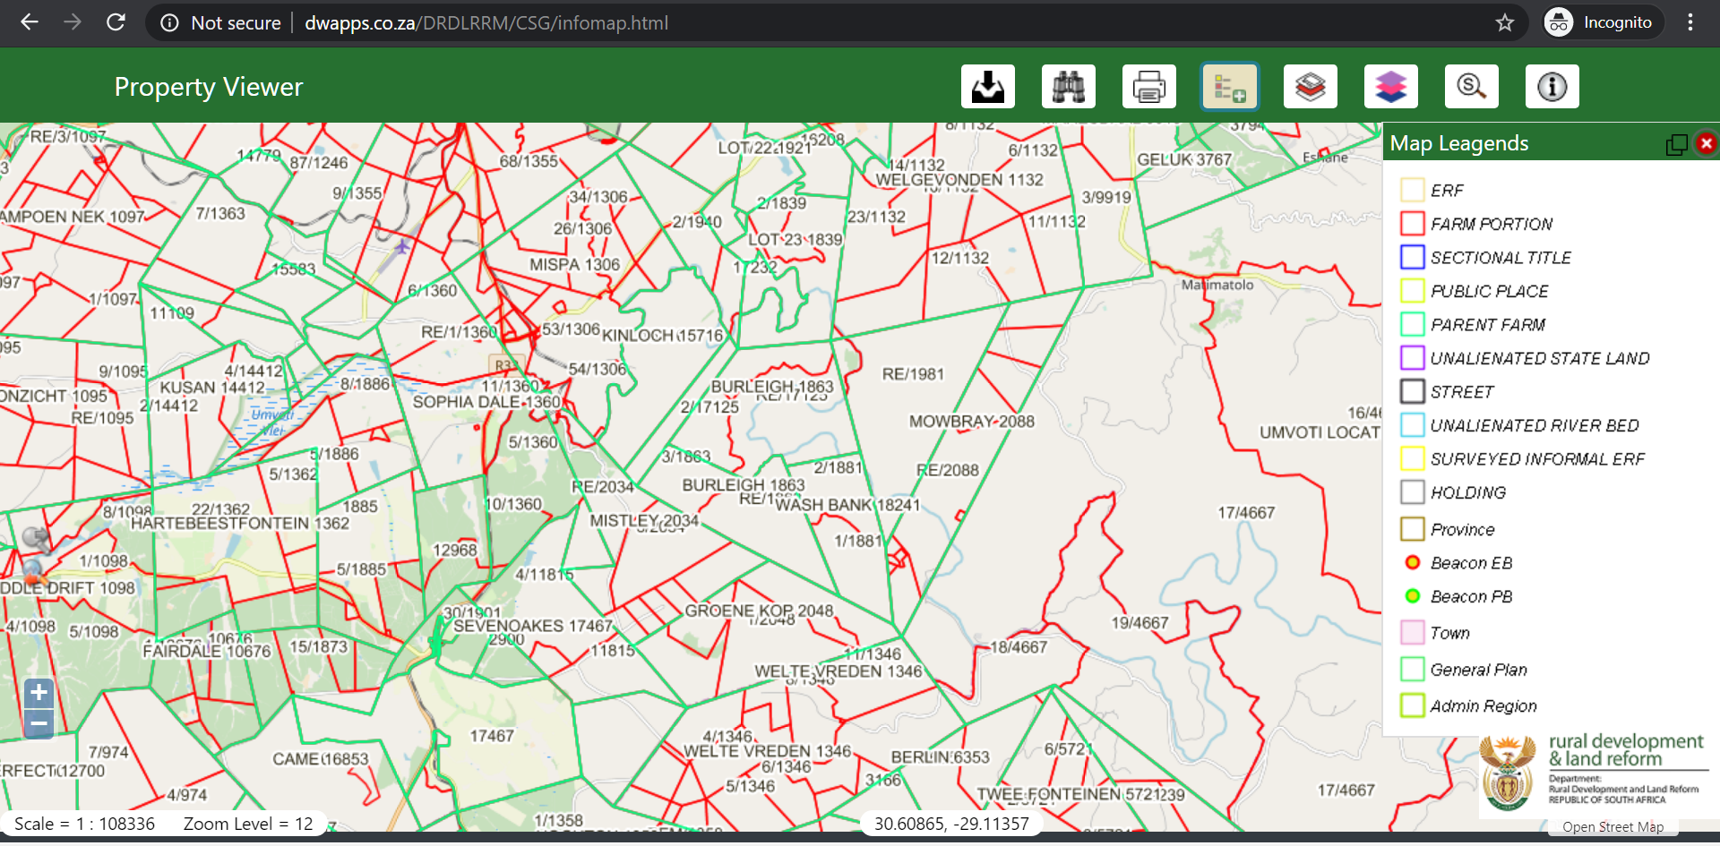The insert below is the sample of the spatial viewer that will be developed as part of the CIS.

Figure 2: The Spatial Viewer

# Functional Requirement 1 - Spatial Viewer

The sections below detail all the functional requirements of the Spatial viewer as previously listed on the Business Requirement Section on Section 4 above.

## Search Tool

1. The Spatial Viewer shall have the following search types:
   1. Attribute Search
   2. Search by Graphics
   3. Search by Street Address
2. The table below shows the search types from the spatial component and what search types the user can have access to including what information the user can get. The Unregistered user will be able to search and view information but NOT download.

| Province | Municipality* | Search Type | Search Filter | Images | Spatial | Alpha  Numeric | Registered User | Unregistered User |
| --- | --- | --- | --- | --- | --- | --- | --- | --- |
| X | (as per selected) province, not mandatory) | Number | SG Number | **X** | **X** | **X** | **X** | **X** |
| X | Number | Compilation | **X** |  | **X** | **X** |  |
| X | Parcel Description | Farm | **X** | **X** | **X** | **X** | **X** |
| X |  | Erf/Holdings | **X** | **X** | **X** | **X** | **X** |
|  |  | LPI | **X** | **X** | **X** | **X** | **X** |
| X | Graphics |  | **X** | **X** |  | **X** |  |
| X | Street Address |  |  |  |  | **X** | **X** |
| X | Alpha Numeric Tool | LPI Code  Allotment/Township  General Plan  Coordinate  Sectional Title  Farm  Parcel |  |  | **X**  **X**  **X**  **X**  **X**  **X**  **X** | **X**  **X**  **X**  **X**  **X**  **X**  **X** |  |

Table 4 : Spatial Search Criteria

The following sections give details of how each of the search types will work.

### Attribute Search Business Rules

1. The Attribute Search functionality allows the user to find the desired feature(s) based on a selected criterion. When the user clicks on the search button, it opens a small window with two tabs, tasks, and results. Tasks tab allows the user to set the selection criteria, results tab allows the user to view the search outcome. This selection can be made using multiple parameters as well. Once the user selects Province, the user will have two options:
   1. Municipality
   2. Administrative District/Registration Division.
2. The Municipality dropdown will have all the Local, District and Metropolitan municipalities in the selected Province.
3. The Administrative District/Registration Division will have all the Administrative Districts/Registration Divisions in the selected Province
4. The following is the sequence of these parameters/attributes search in a Province, (please not the Municipality field will be included in the search parameters but made optional):
   * 1. Region, Parcel, Portion
     2. Farm Name
     3. Allotment Area, Erf, Portion
     4. SG #
     5. LPI Code

Once the user selects Province, the subsequent dropdown will have all the Administrative Districts/Registration Divisions in the selected Province. If the user conducting the search is unsure of the Municipality or Administrative District/Registration Division, the search result will have all the records in the entire province.

* 1. Administrative District/Registration Division
     1. Region, Parcel, Portion
     2. Farm Name
     3. Allotment Area, Erf, Portion
     4. SG #
     5. LPI Code

1. The Administrative District/Registration Division should not be mandatory.
2. In a case where the user only enters the numbers without preceding zeros for ERF/Farm/Portion, the system will automatically pad them to perform the search.
3. Upon successful retrieval of search results the system shall present a results grid.
4. The user should select an item from the result grid so that they can get more download or view information regarding that selected item.
5. The system will have a button on the result table that will allow the user to get more attributes
6. The system shall present the following as part of the get more attributes, web services, which will return data from views in the Alphanumeric database
   1. Spatial Data
   2. Alpha Numeric Data
   3. Image Links
7. The system will check if any of the items in (j) above are within the configurable size/feature count limit.
8. If the items are below the threshold the system shall allow the user to download that as a single request.
9. If the items are above the threshold the system shall allow the user to initiate a bulk request.

### Attribute Search Process Flow



Figure 3: Attribute Search Process Flow

### Attribute Search Action Node Description

| **Node #** | **Description** | **Information to Capture** | **User** |
| --- | --- | --- | --- |
| 1 | At this node, the user shall select the search by attributes search type. The user shall enter the search attributes. | 1. Province 2. Municipality 3. Region, Parcel, Portion 4. Farm Name 5. Allotment Area, Erf, Portion 6. SG # 7. LPI Code | User |
| 2 | At this point the user shall click on the search button to submit the search attributes so they can be queried by the system. The system shall check if there is any information from the search criteria. | Search () | User |
| 3 | At this node, the information that the user was looking for cannot be found. The system shall display the relevant information not found message that is configured for exception handling at this point. At this node, the system should allow the user to choose to go back to node 1, to restart the search. |  | System |
| 4 | At this node, the information that the user searched for can be found on the system. The system shall display the search results on the result grid. |  | System |
| 5 | The user shall select an item from the search result grid that they want information for. The user can be able to click on the **get more attributes** icon from the search results. This function will bring more information about the item like, Alpha Numeric Data and the Image Links. The system checks the size/count. | 1. Select Item () 2. Spatial Data 3. Get More Attributes Click () 4. Alpha Numeric Data* 5. Image Links* | Registered User |
| 6 | At this node, the size/count of the output is more than the configured size on the system. The user will click on the option to initiate a bulk request. The system shall redirect the registered user to the Information Management Module screen to trigger bulk request. | Bulk Request () | Registered User |
| 7 | At this node, the size/count of the output is less than the configured size on the system. The user will be given the option to download the data. | Download () | Registered User |
| 8 | At this the system shall ask the user if the input data is correct. If the user insists that the input data is correct, then the system shall prompt the user to notify the Manager. The user shall click on the option to notify The Manager. If no is selected the process shall end. The user can go back to node 1 from here. | 1. Are You sure your input data is correct? **Yes/No** 2. Do you want to notify The Manager? Yes/No | Registered User |

Table 5: Attribute Search Action Node Description

### Attribute Search Use Case Diagram



Figure 4: Attribute Search Use Case Diagram

### Attribute Search Use Case Description

|  |  |  |
| --- | --- | --- |
| **USE CASE 1.1** | | |
| Search by Attributes | | |
|  | System | |
|  | Unregistered User | |
|  | Registered User | |
|  | National System Administrator | |
|  | Provincial System Administrator | |
| **Preconditions** | 1. The Registered Users have email addresses. 2. The network and database are up. 3. The user has some information request they want to view or download. 4. The user wants to search the system using the search by attributes. | |
| **Business Rules** | 1. The system will keep a log for all activity happening on the Spatial Viewer 2. Both Internal and external registered users will access the same tools on the Spatial Viewer 3. Data validation and completeness rules will be applied by the system and relevant messages displayed should there be any disparities. 4. The system will not allow the user to submit an information request if the data validation rules were violated. 5. The database is updated all the time when a change happens. | |
| **Process** | Search by Attributes | |
| **Sub Process** | Select Search by Attributes Type | |
| Select Attributes | |
| Search with the Attributes | |
| Validate data availability | |
| Display Results on the Grid | |
| Select Item from the Grid | |
| Validation of configured size and count | |
| Download Information | |
| Trigger Bulk Request | |
| **Basic Flow of Events** | **User** | **System** |
| 1. Click on attributes search 2. Enter the attributes to search with 3. Click on the search button to submit the search |  |
|  | 1. Validate the data entered by the user 2. If there is not data or an error in the input, display the relevant message 3. Save the query as entered by the user, fetch the query results, |
|  | 1. Display the result Grid |
| 1. Select an item from the result grid |  |
|  | 1. Check size or count of features compared to the configured values |
| 1. Click on the download button to download the data |  |
|  |  | 1. Download the data |
|  |  | 1. Populate Information on the reports |
| **Alternative Flow of Events** | 5.a) There is no data from the search query   1. The system shows the relevant message to the user (exception handling) 2. The user will also be presented with an option to validate of the data they entered is correct. (if correct the user will be given an option to notify the Manager)   10.a)The information is above the configured size   1. The download option is disabled 2. The user can only submit a bulk request 3. The user clicks submit bulk request 4. The system triggers a bulk request on the Information Management Module and passes the parameters below    * 1. Requestor Information      2. Request Information      3. Search Parameters (LPI code, output type, Layer name, Province, List of Coordinates) | |
| **Notes** | * **Document upload functionality will be a common feature for all processes where necessary** * **Comment Text Box shall be a common feature throughout the system** | |

Table 6: Attribute Search Use Case Description

The Insert overleaf is a sample of the attribute search on the CIS.

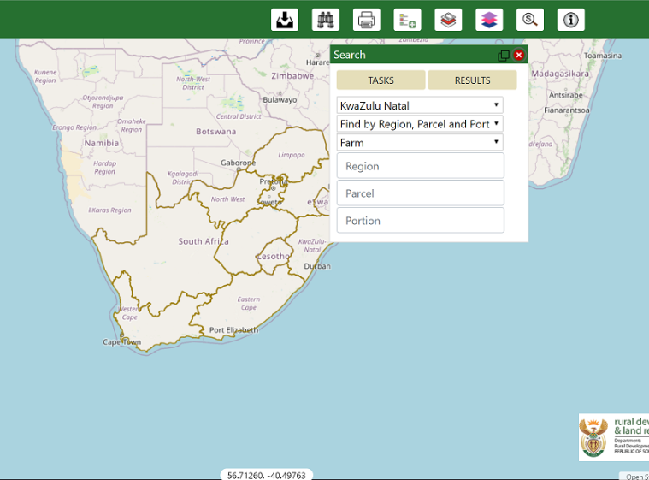

Figure 5: Sample Attribute Search Screen

### Search by Graphic Business Rules

1. This search shall be available to Registered Users.
2. For the users above they need to be logged in to the system so that they can access this functionality.
3. If they are not logged in, the system will treat them as unregistered.
4. This search should be executed within one Province.
5. The system will keep track of the downloads that the user fetches through this search interface. These downloads shall be put into the reports for Information which should be available through the Information Management Module reports.
6. The user will be given the following options for the graphic search to use;
   1. Polygon
   2. Rectangle
   3. Point
   4. Circle
7. The system shall allow the user to draw the graphic on their area of interest
8. The system shall allow the user to select their output type which can be one of the following
   1. Shapefile
   2. KML
   3. WKT
   4. **Image(default)**
   5. DXF
9. The system will default the search output type to Images.
10. After the user has selected their output type as mentioned on h) above the system will do a Spatial query on the predefined set of layers;
    1. Allotment/Township
    2. Beacon
    3. ERF
    4. ERF Portion
    5. Farm
    6. Farm Portion
    7. General Plan
    8. Holding
    9. Holding Portion
    10. Lease
    11. Local Municipality
    12. Parent Farm
    13. Proclamation Boundary
    14. Public Place
    15. Sectional Title
    16. Servitude
    17. Surveyed Informal ERF
    18. Un-alienated Riverbed
    19. Un-alienated State Land
11. Not all the layers will result in image output
12. The user shall be able to select a radio button so that each spatial query can be run on a Layer.
13. The system will display the count against each layer within the graphic.
14. Once a user selects a radio button and the count is done, a checkbox will appear next to that specific layer for the user to tick.
15. Users will be able to tick multiple check boxes, to allow multiple layers to be requested
16. The system will allow the user to download the data if within the configurable size/count. (for downloads the user needs to be logged in)
17. If the data is within the configurable size/count the user can download the zip file.
18. If the data is more than the configured size/count limit, the system will do the following:
    1. Initiate a bulk request, (to execute this the user needs to be logged in).
    2. Redirect the user to the Information Management Module.
    3. The request that will be passed over to the Information Management Module shall contain the following:
       1. Requestor Information
       2. Request Information
       3. Search Parameters
          1. List of LPI code,
          2. Output type,
          3. Layer name,
          4. Province,
          5. List of Coordinates,
19. Should the user request the data in (r) above, the system shall do the following:
    1. Allow the user to initiate a bulk request through the Information Management Module
    2. Allow the user to capture additional information about the request
    3. Allow the user to initiate the bulk request to the Information Manager
    4. Send a link to execute a service to generate a zip file with the submitted request.
    5. At the time of **effecting** the task, the Information Manager or the Information Officer shall click on this link to generate the zip file with the requested data.

### Search by Graphic Process Flow

### 

Figure 6: Search by Graphic Process Flow

### Search by Graphic Action Node Description

| **Node #** | **Description** | **Information to Capture** | **User** |
| --- | --- | --- | --- |
| 1 | At this node, the registered user shall select the search by graphic tool. The user will also select the drawing that they want to use for searching on the spatial viewer | 1. Polygon 2. Rectangle 3. Circle 4. Point | Registered User |
| 2 | The user shall select the desired output type for the search criteria. | 1. Shapefile 2. KML 3. WKT 4. Image 5. DXF | Registered User |
| 3 | At this node, the user shall search by physically drawing on the spatial viewer on the area of interest. | 1. Area of Interest 2. Polygon 3. Rectangle 4. Circle 5. Point | Registered User |
| 4 | At this node, the user shall select the layers that they want information for from the layer list. The system will display the number of records in the layer selected. The user can select one radio button at a time to return the results. The system shall check the selection against the configured size/count. The user can also select the checkbox to request multiple layers. | 1. Layer Radio Button 2. Layer Checkbox | Registered User |
| 5 | At this node, the size/count of the output is less than the configured size on the system. The user will be given the option to download the data. | Download () | Registered User |
| 6 | At this node, the size/count of the output is more than the configured size on the system. The user will click on the option to trigger bulk request. The system shall redirect the user to the Information Management Module screen to trigger bulk request. | Bulk Request () | Registered User |

Table 7: Search by Graphic Action Node Description

### Search by Graphic Use Case Diagram



Figure 7: Search by Graphic Use Case Diagram

### Search by Graphic Use Case Description

|  |  |  |
| --- | --- | --- |
| **USE CASE 1.2** | | |
| Search by Graphic | | |
|  | System | |
|  | Registered User | |
|  | National System Administrator | |
|  | Provincial System Administrator | |
| **Preconditions** | 1. The Registered Users have email addresses. 2. The network and database are up. 3. The user has some information request they want to view or download. 4. The user wants to search the system using the search by graphic tool. | |
| **Business Rules** | 1. The system will keep a log for all activity happening on the Spatial Viewer 2. Both Internal and external registered users will access the same tools on the Spatial Viewer 3. Data validation and completeness rules will be applied by the system and relevant messages displayed should there be any disparities. 4. The system will not allow the user to submit an information request if the data validation rules were violated. 5. The database is updated all the time when a change happens. | |
| **Process** | Search by Graphic | |
| **Sub Process** | Select Graphic | |
| Select Output Type | |
| Select Area of Interest by Drawing | |
| Display Layers and Count | |
| Validation of configured size and count | |
| Download Information | |
| Trigger Bulk Request | |
| **Basic Flow of Events** | **User** | **System** |
| 1. Click on graphic use for searching the system 2. Polygon 3. Rectangle 4. Circle 5. Point |  |
|  | 1. Enable search using that graphic. |
| 1. Select the desired output type: 2. Shapefile 3. KML 4. WKT 5. Image 6. DXF |  |
|  | 1. Save the selected output type as entered by the user. |
| 1. Draw using the selected graphic on the area of interest |  |
|  | 1. Save the query as entered by the user, fetch the query results, check if size or count of features compared to the configured values |
| 1. Select the layers to download and click on the download button to download the data; 2. Layer Radio Button 3. Layer Checkbox |  |
|  |  | 1. Download the data |
|  |  | 1. Populate Information on the reports |
| **Alternative Flow of Events** | 7.a)The information is above the configured size   1. The download option is disabled 2. The user can only submit a bulk request 3. The user clicks submit bulk request 4. The system triggers a bulk request on the Information Management Module and passes the parameters below    * 1. Requestor Information      2. Request Information      3. Search Parameters (LPI code, output type, Layer name, Province, List of Coordinates)      4. Link for data download (zip file) | |
| **Notes** | * **Document upload functionality will be a common feature for all processes where necessary** * **Comment Text Box shall be a common feature throughout the system** | |

Table 8: Search by Graphics Use Case Description

The insert below is the sample screen of the Search by Graphic Tool.

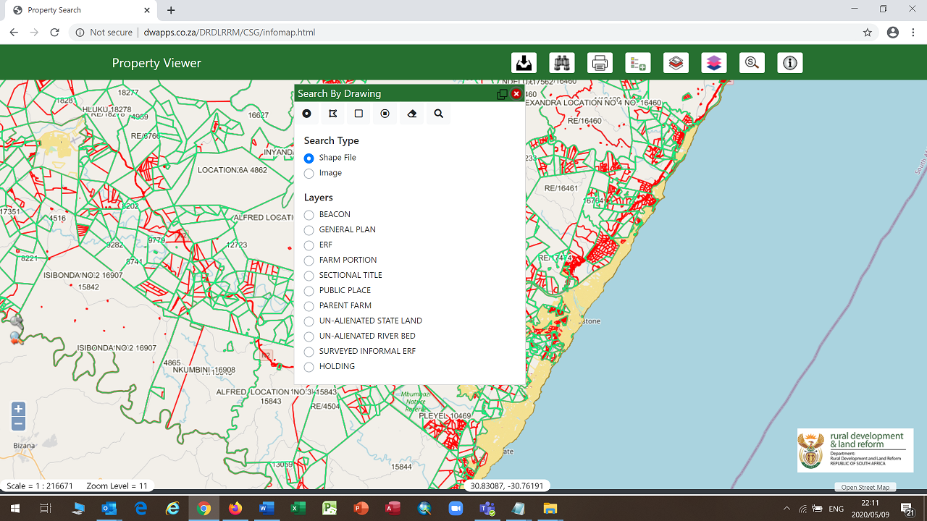

Figure 8 : Sample Search by Graphics

### Street Address Search – Business Rules

1. The Street Address Search will be executed using Bing which is a web search engine owned and operated by Microsoft.
2. The system will allow the user to enter the street number and name for example: 5 Rivonia Road
3. If the system finds only one result the system will zoom to that address on the map.
4. If there are more than one search results found, the system will return a collection of the top 10 results.
   1. The User shall select the one appropriate to them.
   2. The System shall zoom to that address.
5. Using the identify tool the user can find information from the area of interest
6. If there is no address found, the system shall display the appropriate message to the user (exception handling).
7. This enabling/disabling address search should be configurable.
8. This search will also cater for finding places by name.

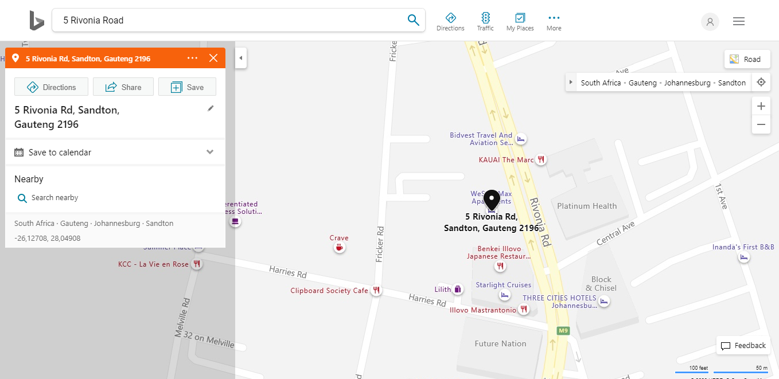The insert below is a sample screen for the Street Address Search using Bing

Figure 9: Sample Big Street Address Search Screen

## Map Navigation Tools – Business Rules

1. The Map **Navigation Tools** will have the following functions.
2. **Zoom to Previous**
   1. Zoom to Previous always active even in first time load because default map extent is the world boundary envelope and the we need to zoom to the country boundary**.**
   2. Clicking on Zoom to Previous will then re-zoom the map window such that it zooms to the previous map extent.
3. **Zoom to Next** 
   1. Is only active once a user has already performed a “Zoom to Previous” operation in the viewer.
   2. Clicking on Zoom to Next will then re-zoom the map window such that it zooms to the next map extent
4. **Zoom to Full extent** 
   1. A user will click on Zoom to full extent to have the map zoom to its full viewing area (in this case it should be the full spatial extent of South Africa).
5. **Zoom Using Bounding Box** 
   1. A user will click the shift key on the keyboard and draw a bounding box by keeping the left mouse button held down until they have completed the drawing
   2. The four vertices of the drawn rectangle will be used to resize and re-render the map, such that the map will now be zoomed in to the level of the drawn rectangle
   3. When the zoom to bounding box tool is used, the longer edge of the drawn rectangle will be used to compute the new map view/ map extent
6. **Zoom by Mouse Scroll**
   1. A user will be able to zoom in and out of the map by scrolling their mouse (using either the mouse wheel or similar).
   2. Each scroll of the mouse will typically result in a change of a single fixed zoom level
7. **Fixed Zoom**
   1. Fixed zoom refers to the fixed zoom levels as per the published map in GeoServer
   2. Each fixed zoom clicks **(+ or -)** will either zoom the map in or out by a single zoom level respectively
8. **Zoom to Coordinates**
   1. A user will enter a set of geographical co-ordinates (Single y,x point, Lat Long, or D.ddd) into the co-ordinate text boxes which appear when activating the Zoom to co-ordinates tool)
   2. The map window will then re-center and re-render based on the center point of the map now being the co-ordinates specified by the user
   3. A user will enter the desired coordinates they wish to zoom to. The Zoom to coordinates tool will also contain an editable text box which shows the current scale of the map. The user will be allowed to modify or change this scale, such that the map will re-center based on the user-input co-ordinates, at the scale specified by the user
9. **Zoom to Scale** 
   1. A user will enter a specified scale into the text box which will appear when activating the Zoom to Scale tool
   2. The map viewer will then re-render and display at the user specified scale
   3. The centre of the map will remain as it was prior to the zoom to scale operation
10. **Pan Tool** 
    1. A user will use the pan tool to navigate and move the map either left, right, up, or down (West, East, North, South)
    2. The scale or zoom level of the map will not change during this operation
11. The User will be able to increment/decrement a fixed zoom level by operating **+/-** buttons.

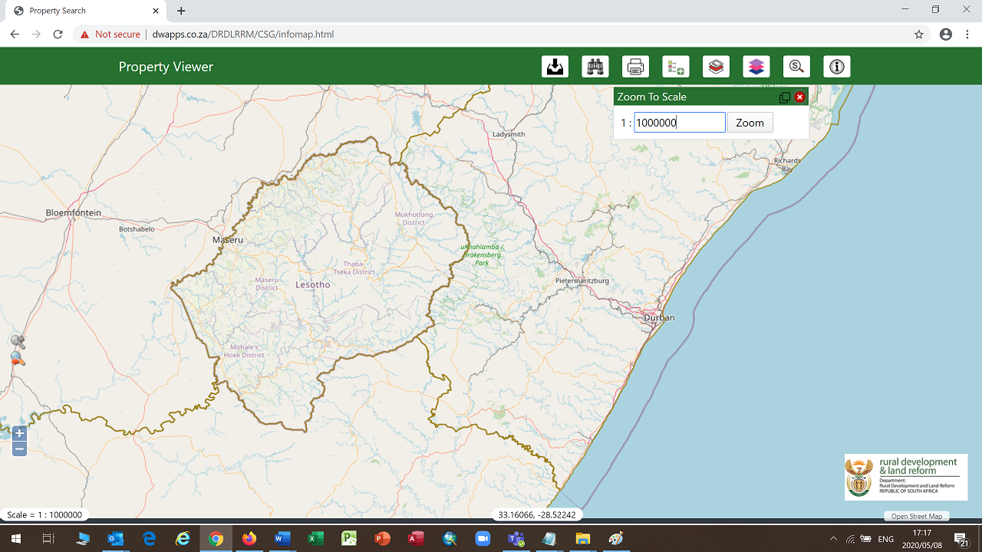The insert below shows a typical **Map Navigation Tool** using the function of **Zoom to Scale Function**

Figure 10: Sample Map Navigation Tool Screen

## Identify Tool Business Rules

1. The identify function can be described as a tool to select a feature/features and retrieve all the associated attribute information of the identified feature(s). It displays the information in a table that appears once the user clicks on a feature on the map using the identify tool.
2. In a case where the tool selects multiple features/layers, the information can be seen by selecting the feature number (Select 1,2, 3...).
3. The Identify Tool will have the following:
4. Standard Identify Function
5. Get More Attributes Function (envisaged attributes)
6. Attribute Table related to the identify function
7. Attribute data related to the attribute table
8. Primarily, a few attributes such as LPI Key, Parcel Type Description are displayed, (the comprehensive list is being finalised).
9. There will be a button to get “Additional Attributes” from the alpha data.
10. The set of additional attributes for the identified record will be returned from a web service which will query the alpha data, utilizing the LPI Key as the primary query indicator.
11. It is anticipated that a series of queries or a view will need to be executed on the alpha database, searching for information corresponding to the respective LPI Key across various tables. As per current known requirements, the additional attributes to be fetched via the web service will be:
    * + 1. Sectional Titles
        2. Servitudes
        3. Lease
        4. Survey records
        5. Subdivision Diagram
        6. Consolidation Diagram
        7. Substitution Diagram
        8. Sect/Art 16 Diagram
        9. General Plan
        10. Sub divisional General Plan
        11. Curvilinear Boundary Diagram
        12. Beacon Agreement
        13. Servitude Plans
        14. Proclamation Diagram
        15. Mining Diagram
        16. International Boundary Diagram
        17. Dummy Diagram
        18. Compilation Sheet
        19. Correspondence File
        20. Farm Comp
        21. Miscellaneous Plan
12. There will be a link to download the image for each record (where available).
13. There will be multiple links to Images of records linked to a parcel or Servitude. It must be noted that there is a one to many relationships between a parcel/spatial object and images.

The insert below depicts the typical Identify Tool with a Table showing the attributes

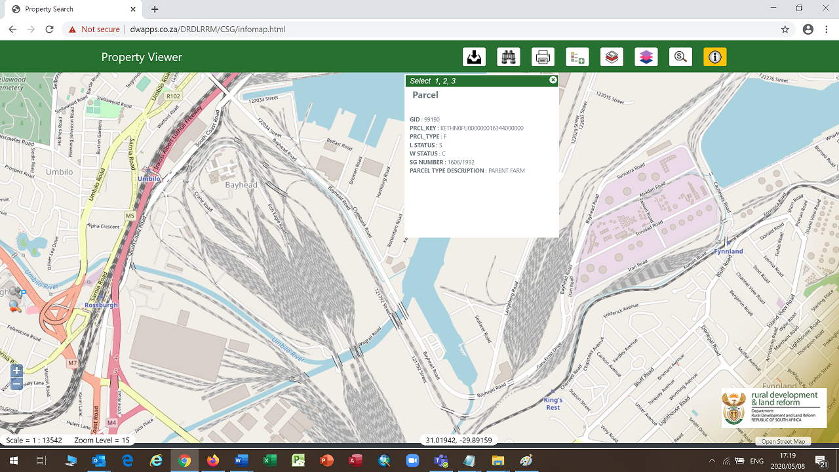

Figure 11: Sample Identity Tool

## Share View Tool Business Rules

The **Share View Tool** will be developed with the following rules:

1. Share – Ability to share the map through a link to other users via email with the state of the map i.e. extent, display of layers based on the selection
2. A user will use the “Share View” tool to share a hyperlink with other users.
3. This hyperlink will be generated by the Spatial Viewer and will be used to maintain and recreate the state of the map view as at the point at which the hyperlink was shared.
4. Items which will be maintained will be the map extent/ map envelope position and scale, as well as the layers which are toggled on/ off at the point of hyperlink creation.
5. It should be noted that whilst the hyperlink will be generated at a specified time, if there have been any data changes after the sharing of the hyperlink, the latest available version of the data will be displayed when the hyperlink is used.
6. The user will click “Share View” to enable the Share view tool.
7. The user will enter the email address of the user whom they want to share the created hyperlink with, and then click “Share”
8. The hyperlink will be sent from the Information Management Module as a notification.
9. The recipient of the email notification will be able to click the hyperlink as received in the email, and the Spatial Viewer will then be opened and focused to the same map envelope and layer selection as per the generated hyperlink.

## Print and Export Tool Business Rules

### Standard Map Print

The print and export tool will be implemented with the following functional areas:

1. The system will support the following 3 key functionalities for the print and export tool
   1. Print to scale
   2. Export
   3. Print Tool ((projected)
2. The Print Pages Sizes will be:
   1. A4
   2. A3
   3. A2
   4. A1
   5. A0
3. The Orientation shall be
4. Landscape
5. Portrait
6. The Formats shall be
   1. PDF
   2. PNG
   3. JPG
7. The system will allow the user to input a Map Title – A text box to type in a desired title for the map
8. The Map will have a scale.
9. The map will also have an Orientation of True North.

### Print in Projected Coordinate System

1. The Print in Coordinate System Tool - will work as per below:
   1. There will be an option to print the projected map.
   2. User can select the desired Lo band.
   3. The print output will only contain the features/parcels and will not have any backdrop layers such as Open Street Map, Aerial Imagery.
2. The purpose of the “Print in Lo Coordinate system tool” is for a registered user to print what are known as Layoff maps utilizing the Spatial Viewer.
3. The user will have already zoomed to their area of interest on the map viewer and will then click the “Print in Lo Coordinate system tool” icon.
4. The user will then click on the provided dropdown menu and will get a list of Lo bands from which they will need to select their respective Lo band. A tooltip to remind the user to select their correct LO Band will be provided. The Lo Band List will always be the full list.
5. The user will be allowed to print or export the Layoff map which will utilize this re-projected data.
6. Data in the map view will be restricted to the selected Lo band only.
7. The user will also be able to enter a specified scale at which they require the map print to be generated, as well as enter a map title.
8. This print tool will also have a "print to scale" option, as the standard print and export tool does
9. The system will support the following 3 key functionalities for the print and export tool
10. Print to scale
11. Export
12. Print Tool (projected)
13. The Print Pages Sizes will be:
14. A4
15. A3
16. A2
17. A1
18. A0
19. The Orientation shall be
20. Landscape
21. Portrait
22. The Formats shall be
    1. PDF
    2. PNG
    3. JPG
23. The system will allow the user to input a Map Title – A text box to type in a desired title for the map
24. The Map will have a Scale
25. The map will also have an Orientation of True North
26. NGIS dataset should be projectable.

The screen below depicts a sample print Tool

Figure 12: Sample Print Screen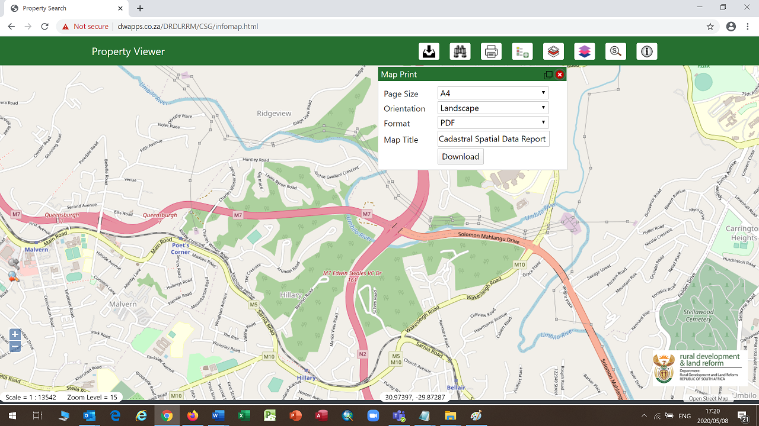

## Bookmark Tool Business Rules

.

1. The bookmark function allows a registered user to save various map extents for later use.
2. The tool allows users to zoom to an area and type in the name of the bookmark.
3. The bookmark is then saved and can be retrieved by clicking on the bookmark name.
4. Registered users will save their own bookmark of a map for future use.
5. The system needs to store the bookmarks.
6. The Bookmarks can be deleted by the user.
7. The system will allow the user to save as many bookmarks as they want.

## Layer Manager Tool Business Rules

1. Layer Manager lists all the layers that are available to view.
2. User can switch on/off the layers as required.
3. Two or more layers can be grouped together thereby allowing the user to switch on/off all the layers within the group with a single check.
4. Only the administrator can do the configuration of these layers/groups.
5. By default, certain layers are switched on.
6. Dynamically switching on a layer at a pre-defined scale is also achieved through the configuration changes on the GeoServer by the administrator.

## Refresh Data Sources Tool Business Rules

The Developmentof the **Refresh Data Sources Tool will be governed by the following business rules**

1. A user will click on the “Refresh Data Sources” button for the map window to have its data re-read from the spatial database.
2. This action should maintain same envelope, same layers toggled as per the user’s map state prior to clicking on the Refresh Data Sources button
3. Data sources will be re-read so that the map reloads and showing the latest version of the data as available in GeoServer.
4. There is a possibility of latency with GeoServer and the handling of the data sources between the source database and GeoServer.

## Reset Map Tool Business Rules

1. **Development o**f a **Reset Map Tool** will have the following business rules:
2. This tool/ button will reset the map view/ window to its default state, so that the map envelope and layers displayed appear as they did when the map was first loaded. *(this is the same as entering “CTRL-F5 on your keyboard)*

## Measure Tool Business Rules

Development of a **Measure Tool will take into consideration the following functionalities.**

1. The measure tools allow the users to calculate:
   1. distances,
   2. areas,
   3. perimeters.
2. A User can click on the tool and select either area or distance.
3. The line and area measurement tools provide segment information as well as total length and area information.
4. The measure results are displayed on the screen.
5. It may be noted that the accuracy of the results is limited by the National Control Survey System (WGS84 Coordinate system) and the accuracy of the spatial data.

## Map Legend Tool Business Rules

1. Development of a **Map Legend** Tool
2. Map legend displays the symbols that represent various features on the map.
3. These symbols are patches (examples) of the features along with the feature name. E.g., A small red rectangle with a text: Provincial Boundary. This represents the provincial boundary on the map. These symbols are for all feature types i.e. Polygons, Lines and Points.

## Alpha Numeric Data Tool Business Rules

1. Development of a standalone Alpha Numeric Data Tool for Registered Logged in users only
2. Using this tool above the users can directly download alpha numeric data from the system without having to go through the generic search criterion which has been tabulated in this document
3. The system will allow the user to download the alpha numeric data to csv or excel.
4. Through the Alpha Numeric Data Tool, the user should be able to search with the following filters the following within a Province.
   * 1. Municipality
     2. Region, Parcel, Portion
     3. Farm Name
     4. Allotment Area, Erf, Portion
     5. SG #
     6. LPI Code
5. This tool will allow the user to get the following information
6. Coordinate lists
7. LPI Code List
8. Allotment/Township List
9. General Plan List
10. Sectional Title List
11. Farm List
12. Parcel List

# Functional Requirement 2 - Spatial Viewer UAM

1. The users will access the Spatial Viewer through the **Web Portal** interface of the CIS.
2. It is worth noting that there will be no separate registration for access to the Spatial Viewer. The **User Access Management Module** shall be used to grant access and permissions to users once they register.
3. Unregistered users will have access to the web portal.
4. The Spatial Viewer will have the following user groupings.
5. Unregistered Users
6. Registered Users
7. System Administrators

The following table specifies all the functionalities and access to be granted to users

| Spatial Viewer Function | Unregistered User | Registered User | System Administrator |
| --- | --- | --- | --- |
| Read/View | **X** | **X** | **X** |
| Download |  | **X** | **X** |
| Register | **X** | **X** | **X** |
| Attribute Search | **X** | **X** | **X** |
| Street Search | **X** | **X** | **X** |
| Search by Graphics |  | **X** | **X** |
| Map Navigation Tools | **X** | **X** | **X** |
| Identify Tool | **X** | **X** | **X** |
| Share View Tool |  | **X** | **X** |
| Print and Export Tool | **X** | **X** | **X** |
| Print in Projected Coordinate System |  | **X** | **X** |
| Bookmark Tool. |  | **X** | **X** |
| Refresh Data Sources Tool | **X** | **X** | **X** |
| Reset Map Tool | **X** | **X** | **X** |
| Measure Tool | **X** | **X** | **X** |
| Layer Manager Tool | **X** | **X** | **X** |
| Map Legend Tool | **X** | **X** | **X** |
| Alpha Numeric Data Tool |  | **X** | **X** |
| Single Requests |  | **X** | **X** |
| Bulk Requests |  | **X** | **X** |
| Spatial Data Extracts (Boundary Data) |  | **X** | **X** |
| Parametrized Viewer |  | **X** | **X** |
| System Administration |  |  | **X** |
| Map Configurations |  |  | **X** |

Table 9: User Functionalities and Access

1. The icons to access the tools listed above will be visible to all users who access the Spatial Viewer, however functionality for registered user components will only be enabled for logged in users. If user is not logged in, these registered user buttons will be greyed out. A tooltip will appear when the un-logged in user clicks on a registered user function, indicating that the user needs to register and login to access these tools.

# Functional Requirement 3 - Spatial Viewer Information Management

The Spatial Viewer will be an application to view Information and query for the spatial information, the spatial viewer will also be used as a trigger point for some Information Requests. These requests can either be single requests or bulk requests.

## Spatial Viewer Single Requests

### Spatial Viewer Single Requests – Business Rules

1. Only Registered Users will be able to execute Single Requests from the Spatial Viewer
2. The system will prompt users to register if they are not registered.
3. The system will prompt users to log in if they are not logged in.
4. The Single Requests would be for the following Information:
   1. Cadastral Documents/Images
   2. Spatial Data
   3. Alpha Numeric Data
5. The System Administrator will configure the number of features and the size for single request downloads.
6. The configuration above shall be done on the Information Management Module of the CIS and not on the Spatial Viewer.
7. The user will be able to use all the search criteria named on the search tools section (5.1) of this document to trigger the Single Requests.
   1. **Attribute Search** – The system will present an option for the user to download the Information once the result has been found. There will be an icon next to the result set for download if the data is within the threshold.
   2. **Search by Graphics** - The system will present an option for the user to download the Information once the result has been found and the user has selected the radio button for the layers they want. There will be an icon next to the result set for download if the data is within the threshold.
   3. **Street Address Search** - The system allows the user to use the identify tool or the other search criteria so that the user can get to the information to download.
8. Should the system not find the data that the user is searching for, an appropriate message will be displayed to the user.
9. Should the system find the data that the user is searching for it shall enable the download button for the user to download the data (if within the threshold)
10. The system will keep track of the Information that is downloaded via the Spatial Viewer
11. This information on (j) above will be shown on the Statistical Report on the Information Management Module
12. Pre-packaged data will not be downloaded via the Spatial Viewer but from a webpage created on the Information Management Module
13. The spatial module will however trigger routines/services to update the pre-packaged data on daily intervals.

### Spatial Viewer Single Request Process Flow



**Figure 13: Spatial Viewer Single Request Process Flow**

### Spatial Viewer Single Request Action Node Description

| **Node #** | **Description** | **Information to Capture** | **User** |
| --- | --- | --- | --- |
| 1 | At this node, the registered user shall select the search criteria they want to search with. | 1. Attribute Search 2. Search by Graphic | Registered User |
| 2 | At this node, the user selected the search by graphic option. The user will have to select the drawing type. | 1. Polygon 2. Rectangle 3. Circle 4. Point | Registered User |
| 3 | The user shall select the desired output type for the search criteria. | 1. Shapefile 2. KML 3. WKT 4. Image 5. DXF | Registered User |
| 4 | At this node, the user shall search by physically drawing on the spatial viewer on the area of interest. | 1. Area of Interest 2. Polygon 3. Rectangle 4. Circle 5. Point | Registered User |
| 5 | At this node, the user shall select the layers that they want information for from the layer list. The system will display the number of records in the layer selected. The user can select one radio button at a time to return the results. The system shall check the selection against the configured size/count. | Layer Select () | Registered User |
| 6 | At this node, the size/count of the output is less than the configured size on the system. The user will be given the option to download the data. | Download () | Registered User |
| 7 | At this node, the size/count of the output is more than the configured size on the system. The user will click on the option to trigger a bulk request. The system shall redirect the user to the Information Management Module screen to trigger a bulk request. | Bulk Request () | Registered User |
| 8 | At this node, the user has selected the search by attributes search type. The user shall enter the search attributes. At this point the user shall click on the search button to submit the search attributes so they can be queried by the system. The system shall check if there is any information from the search criteria | 1. Province 2. Municipality 3. Region, Parcel, Portion 4. Farm Name 5. Allotment Area, Erf, Portion 6. SG # 7. LPI Code | Registered User |
| 9 | At this node, the information that the user was looking for cannot be found. The system shall display the relevant information not found message that is configured for exception handling at this point. The user can go back to the node 1 from here. |  | System |
| 10 | At this node the system shall ask the user if the input data is correct. If the user insists that the input data is correct, then the system shall prompt the user to notify the Manager. The user shall click on the option to notify The Manager. If no is selected the process shall end. The user can go back to node 1 from here. | 1. Are You sure your input data is correct? **Yes/No** 2. Do you want to notify The Manager? **Yes/No** | Registered User |
| 11 | At this node, the information that the user searched for is found on the system. The system shall display the search results on the result grid. The user shall select an item from the search result grid. The user can be able to click on the **get more attributes** icon from the search results. This function will bring more information about the item like, Alpha Numeric Data and the Image Links. The system checks the size/count. | 1. Select Item () 2. Spatial Data 3. Get More Attributes Click () 4. Alpha Numeric Data* 5. Image Links* 6. csv* 7. dbf* 8. excel* | Registered User |

Table 10: Spatial Viewer Single Request Action Node Description

### Spatial Viewer Single Request Use Case Diagram



Figure 14: Spatial Viewer Single Request Use Case Diagram

### Spatial Viewer Single Request Use Case Description

|  |  |  |
| --- | --- | --- |
| **USE CASE 1.3** | | |
| Spatial Viewer Single Request | | |
|  | System | |
|  | Registered User | |
|  | National System Administrator | |
|  | Provincial System Administrator | |
| **Preconditions** | 1. The Registered Users have email addresses. 2. The user is logged on 3. The network and database are up. 4. The user has some information request they want to view or download. 5. The user wants to search the system using the search by graphics tool. 6. The user wants to search the system using the search by Street Address. 7. The user wants to search the system using the search by Attributes Search. | |
| **Business Rules** | 1. The system will keep a log for all activity happening on the Spatial Viewer 2. Both Internal and external registered users will access the same tools on the Spatial Viewer 3. Data validation and completeness rules will be applied by the system and relevant messages displayed should there be any disparities. 4. The system will not allow the user to submit an information request if the data validation rules were violated. 5. The database is updated all the time when a change happens. | |
| **Process** | Spatial Viewer Single Request | |
| **Sub Process** | Select Search Criteria | |
| Search | |
| Select Area of Interest by Drawing | |
| Select the Layer | |
| Select the Search Result | |
| Validation of configured size and count | |
| Download Information | |
| Trigger Bulk Request | |
| **Basic Flow of Events** | **User** | **System** |
| 1. Select the Search Criteria to execute 2. Attribute 3. Graphics |  |
|  | 1. Enable search using that search criteria. |
| 1. Select Graphic to draw with 2. Polygon 3. Rectangle 4. Circle 5. Point |  |
| 1. Enter the output for search 2. Shapefile 3. KML 4. WKT 5. Image 6. DXF | . |
| 1. Draw on the Map using 2. Polygon 3. Rectangle 4. Circle 5. Point |  |
| 1. Select the Layer to get information from using the radio buttons. 2. Beacon 3. General Plan 4. ERF 5. ERF Holdings 6. Farm Portion 7. Public Place 8. Parent Farm 9. Un-alienated State Land 10. Un-alienated Riverbed 11. Surveyed Informal ERF 12. Holding 13. ERF portions 14. Farm Portions 15. Sectional Titles 16. Local Municipality |  |
|  | 1. Check the size/count of the information on the layer selected. |
| 1. Click on the link to download data |  |
|  |  | 1. Download the data |
|  |  | 1. Populate Information on the reports |
| **Alternative Flow of Events** | 3.a) The user selected the attribute search   1. The user enters the attributes to search with 2. Province 3. Municipality 4. Region, Parcel, Portion 5. Farm Name 6. Allotment Area, Erf, Portion 7. SG # 8. LPI Code 9. The user clicks on the search button 10. The system validates the data entered 11. The user selects the item from the result grid 12. The system validates the size/count 13. The Result Item was less than the size/count 14. The system enables the download icon 15. The user downloads the Information 16. The system populates the reports of these requests.   3. a) iii) a) The Search query cannot be found   1. The system displays an exception message. 2. The system prompts for data validation 3. The system prompts for notification of the Manager.   8.a)The information is above the configured size   1. The download option is disabled 2. The user can only submit a bulk request 3. The user clicks submit bulk request 4. The system triggers a bulk request on the Information Management Module and passes the parameters below    * 1. Requestor Information      2. Request Information      3. Search Parameters (LPI code, output type, Layer name, Province, List of Coordinates)   3.a) iv) The user selects the get more attributes function   1. The system prompts the user to select format (dbf, csv, excel) | |
| **Notes** | * **Document upload functionality will be a common feature for all processes where necessary**   **Comment Text Box shall be a common feature throughout the system** | |

Table 11: Spatial Viewer Single Request Use Case Description

## Spatial Viewer Bulk Requests

### Spatial Viewer Bulk Requests - Business Rules

1. Through the spatial viewer registered users shall be able to trigger requests for the following Information: (a detail of this is attached on annexure – Product and Services of this document)
2. The table below shows the Information requests that will be initiated from the Spatial Viewer. This table is based on the scale of fees.

|  |  |  |  |
| --- | --- | --- | --- |
| SQ# | Request Category | Request Subcategory | Items |
| 1. | Cadastral Documents | Images | 1. Sectional Title Plans 2. General Plans 3. Diagrams |
| 2. | Spatial Data | Extraction of Data | 1. Shapefile 2. KML 3. WKT 4. DXF |
| 3 | Alpha Numeric Data | Coordinate List |  |

Table 12 : Spatial Viewer Triggered Information Requests

1. The table below shows the Information requests that will be triggered from the Information Management Module (However the Spatial Module needs to show a contextualised/parametrised view of these). This table is based on the scale of fees.

|  |  |  |  |
| --- | --- | --- | --- |
| SQ# | Request Category | Request Subcategory | Items |
| 1 | **Certificates** | 1. **Certificate of Remainder** 2. **Confirmation of Jurisdictional Boundaries** | 1. **Shape Files** 2. **Shape Files** |
| 2 | Professional Services | 1. Images   Images  Images   1. Extraction of Data   Extraction of Data  Extraction of Data  Extraction of Data   1. Coordinate List 2. Certificate of Remainder 3. Confirmation of Jurisdictional Boundaries | 1. Sectional Title Plans 2. General Plans 3. Diagrams 4. Shapefile 5. KML 6. WKT 7. DXF 8. Shape Files 9. Shape Files |
| 3 | NGI Data | Vector Data | 1. Grids 2. Roads 3. Railway 4. 25 Mint Interval 5. 5M Contours 6. Projected 5M contours |
|  |  | Trig and Town Survey Marks | 1. TSM 2. TRIG |
|  |  | DEM (Digital Elevation Model) | 1. 50M and 100M interval |

Table 13: Information Management Module Triggered Requests

1. The NGI data will be for only the offices that provide NGI data;
2. The Category for professional services will automatically mean that this request needs to be treated as a bulk request and posted onto the Information Management Module for processing
3. The Sequence for triggering bulk requests through the spatial viewer shall be as follows
   1. The User searches with the predefined search criteria;
   2. The user selects the output
   3. The system performs the search and returns the results
   4. The user selects the layers that they want information for
   5. The system validates the size/count based on the configuration (In a scenario where the size/count is more than the configured)
      1. The system presents an option to trigger a bulk request
      2. The user is redirected to the Information Management Module to capture more details about the bulk request
      3. The request that will be passed over to the Information Management Module shall contain the following:
      4. Requestor Information
      5. Request Information
      6. Search Parameters
         * List of LPI codes,
         * Output type,
         * Layer name,
         * Province,
         * List of Coordinates,
4. From the Spatial Module the system will **send** a **link** to execute a **service** to generate the zip file should the user want the data .At the time of effecting the task, the Information Officer can **click** on this **link** to generate the zip file which will have the Information requested by the user through the spatial viewer..
5. Once the request has been passed over to the Information Management Module, the normal bulk process shall ensue from the Information Management Module, until the request is dispatched.
6. Alpha Numeric Data should be for Coordinate List and can be exported to the following:
   1. csv
   2. excel
   3. dbf
7. These requests shall form part of the reports on the Information Management Module reports.

### Spatial Viewer Bulk Requests – Process Flow



Figure 17: Spatial Viewer Bulk Requests – Process Flow

### Spatial Viewer Bulk Requests – Action Node Description

| **Node #** | **Description** | **Information to Capture** | **User** |
| --- | --- | --- | --- |
| 1 | At this node, the registered user shall select the search criteria they want to search with. | 1. Attribute Search 2. Search by Graphic | Registered User |
| 2 | At this node, the user selected the search by graphic option. The user will have to select the drawing type. | 1. Polygon 2. Rectangle 3. Circle 4. Point | Registered User |
| 3 | The user shall select the desired output type for the search criteria. | 1. Shapefile 2. KML 3. WKT 4. Image 5. DXF | Registered User |
| 4 | At this node, the user shall search by physically drawing on the spatial viewer on the area of interest. | 1. Area of Interest 2. Polygon 3. Rectangle 4. Circle 5. Point | Registered User |
| 5 | At this node, the user shall select the layers that they want information for from the layer list. The system will display the number of records in the layer selected. The user can select one radio button at a time to return the results. A Checkbox option shall be available for multiple selection of layers. The system shall check the selection against the configured size/count. | Select Layer ()   1. Layer Radio Button 2. Layer Checkbox | Registered User |
| 6 | At this node, the size/count of the output is less than the configured size on the system. The user will be given the option to download the data. | Download () | Registered User |
| 7 | At this node, the size/count of the output is more than the configured size on the system. The user will click on the option to trigger a bulk request. The system shall redirect the user to the Information Management Module screen to trigger a bulk request. | Bulk Request () | Registered User |
| 8 | At this node, the registered user shall be on the Information Management Module as redirected from the spatial viewer. The user can view the request information in addition the user can enter more information about the request. The user can then submit the bulk request at this point. | 1. Packaging* 2. Delivery Mode 3. Submit () | Registered User |
| 9 | At this node, the user has selected the search by attributes search type. The user shall enter the search attributes. At this point the user shall click on the search button to submit the search attributes so they can be queried by the system. The system shall check if there is any information from the search criteria | 1. Province 2. Municipality 3. Region, Parcel, Portion 4. Farm Name 5. Allotment Area, Erf, Portion 6. SG # 7. LPI Code | Registered User |
| 10 | At this node, the information that the user was looking for cannot be found. The system shall display the relevant information not found message that is configured for exception handling at this point. The user can have the option of going to node 1. |  | System |
| 11 | At this the system shall ask the user if the input data is correct. If the user insists that the input data is correct, then the system shall prompt the user to notify the Manager. The user shall click on the option to notify The Manager. If no is selected the process shall end. The user can go back to node 1 from here. | 1. Are You sure your input data is correct? **Yes/No** 2. Do you want to notify The Manager? Yes/No | Registered User |
| 12 | At this node, the information that the user searched for is found on the system. The system shall display the search results on the result grid. The user shall select an item from the search result grid that. The user can be able to click on the **get more attributes** icon from the search results. This function will bring more information about the item like, Alpha Numeric Data and the Image Links. The system checks the size/count. The user can select the format if get more attributes is chosen. | 1. Select Item () 2. Spatial Data 3. Get More Attributes Click () 4. Alpha Numeric Data* 5. Image Links* 6. Csv* 7. Excel* 8. Dbf* | Registered User |

Table 14: Spatial Viewer Bulk Requests – Action Node Description

### Spatial Viewer Bulk Requests – Use Case Diagram



Figure 18: Spatial Viewer Bulk Requests – Use Case Diagram

### Spatial Viewer Bulk Requests – Use Case Description

|  |  |  |
| --- | --- | --- |
| **USE CASE 1.4** | | |
| Spatial Viewer Single Request | | |
|  | System | |
|  | Registered User | |
|  | National System Administrator | |
|  | Provincial System Administrator | |
| **Preconditions** | 1. The Registered Users have email addresses. 2. The user is logged on. 3. The network and database are up. 4. The user has some information request they want to view or download. 5. The user wants to search the system using the search by graphics tool. 6. The user wants to search the system using the search by Street Address. 7. The user wants to search the system using the search by Attributes Search. 8. The user wants to submit a request to the office for processing this can be f 9. The request is above the number of features configured on the system 10. The request is above the size configured on the system | |
| **Business Rules** | 1. The system will keep a log for all activity happening on the Spatial Viewer 2. Both Internal and external registered users will access the same tools on the Spatial Viewer 3. Data validation and completeness rules will be applied by the system and relevant messages displayed should there be any disparities. 4. The system will not allow the user to submit an information request if the data validation rules were violated. 5. The database is updated all the time when a change happens. | |
| **Process** | Spatial Viewer Bulk Request | |
| **Sub Process** | Select Search Criteria | |
| Search | |
| Select Area of Interest by Drawing | |
| Validation of Information Availability | |
| Select Layer | |
| Select Output Item from Result Grid | |
| Validation of configured size and count | |
| Single Request(download) | |
| Submit Bulk Request to Information Management Module | |
|  | Review/Capture/Submit Bulk Request on Information Management Module | |
| **Basic Flow of Events** | **User** | **System** |
| 1. Select the Search Criteria to execute 2. Attribute 3. Graphics |  |
|  | 1. Enable search using that search criteria. |
| 1. Select Graphic to draw with 2. Polygon 3. Rectangle 4. Circle 5. Point |  |
| 1. Enter the output for search 2. Shapefile 3. KML 4. WKT 5. Image 6. DXF | . |
| 1. Draw on the Map using 2. Polygon 3. Rectangle 4. Circle 5. Point |  |
| 1. Select the Layer to get information from using the radio buttons. 2. Beacon 3. General Plan 4. ERF 5. Farm Portion 6. Public Place 7. Parent Farm 8. Un-alienated State Land 9. Un-alienated Riverbed 10. Surveyed Informal ERF 11. Holding 12. ERF portions 13. Farm Portions 14. Sectional Titles 15. Local Municipality 16. Select Layer Checkbox |  |
|  | 1. Check the size/count of the information on the layer selected. |
| 1. Click on the icon to submit bulk Request |  |
|  |  | 1. Redirect user to the Information Management Module Capture Request Screen |
|  | 1. Review Request and capture other information related to the request like: 2. Dissemination Medium 3. Packaging and submit the bulk Request |  |
|  |  | 1. Trigger Bulk Request on the Information Managers Inbox |
| **Alternative Flow of Events** | 3.a) The user selected the attribute search   1. The user enters the attributes to search with 2. Province 3. Municipality 4. Region, Parcel, Portion 5. Farm Name 6. Allotment Area, Erf, Portion 7. SG # 8. LPI Code 9. The user clicks on the search button 10. The system validates the data entered 11. The user selects the item from the Result Grid 12. The system validates the size/count 13. The Result Item was more than the size/count 14. The system triggers a bulk request 15. The user submits the bulk request to the Information Management Module 16. The user fills in more information about the request and submits the bulk request.   5. a) iii) a) The Search query cannot be found   1. The system displays an exception message.   8.a)The information is below the configured size   1. The download option is enabled 2. The user can download the information 3. The system should populate this information on the reports   3.a) iv) The user selects the get more attributes function   1. The system prompts the user to select format (dbf, csv, excel) | |
| **Notes** | * **Document upload functionality will be a common feature for all processes where necessary**   **Comment Text Box shall be a common feature throughout the system** | |

Table 15: Spatial Viewer Bulk Requests – Use Case Description

## Parametrised Viewer

### Parametrised Viewer Business Rules

1. The system shall display a parametrised spatial viewer for logged in registered users based on the following events:
   1. The User Searches for a parcel from the Information Management Module.
   2. The system displays the results set.
   3. The system displays a Globe Icon next to the result set that has spatial data.
   4. Upon clicking on the globe, the system zooms to that parcel.
2. The View map icon/globe will be shown where there is spatial data
3. If there is no corresponding spatial data, the system will not show the globe icon.
4. The user needs to view map and the system will:
   1. Pop up window viewer of the spatial data.
   2. Zoom to the corresponding spatial record
5. Standard Spatial tools will be available with the spatial view like those for the unregistered user.
6. The user should be View /Download the spatial data
7. Logged on report
8. 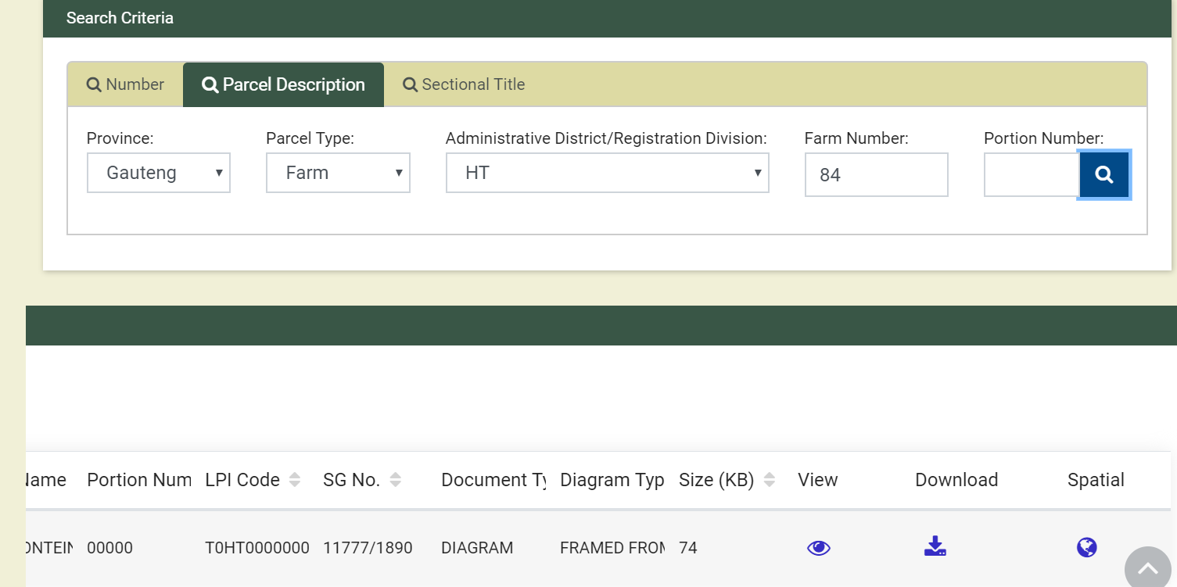The Screen below shows the sample of the search results as per business rule a) above.

Figure 19: Search Screen and Search Results with Spatial Icon

1. The screen below shows the parametrised viewer having zoom onto the parcel that was selected
2. Users should be able see other spatial data layers around and/or over the parcel of interest.

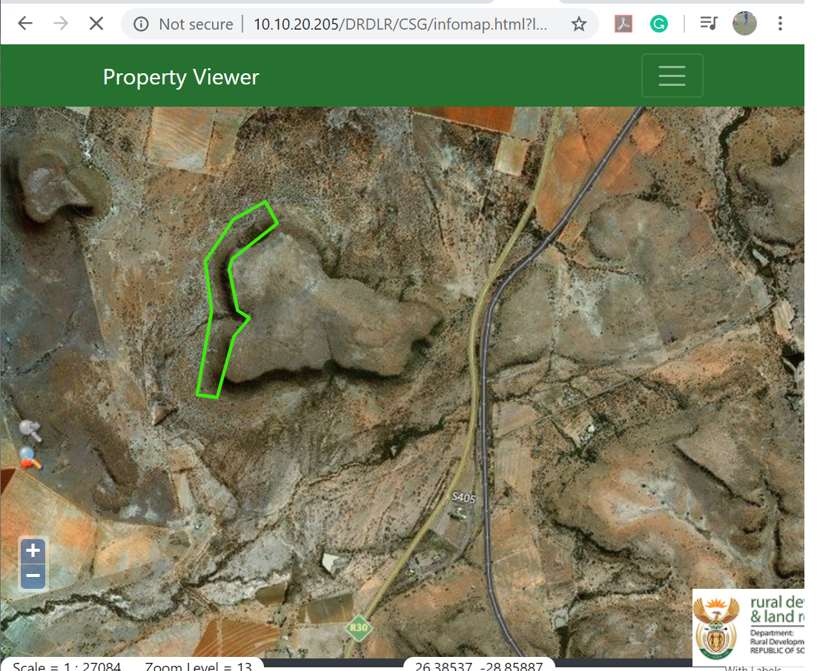

Figure 20: The Screen Zoomed To

### Parametrised Viewer Process Flow



Figure 21: Parametrized Spatial Viewer Process Flow

### Parametrised Viewer Action Node Description

| **Node #** | **Description** | **Information to Capture** | **User** |
| --- | --- | --- | --- |
| 1 | At this node, the registered user shall select the search criteria they want to search with and enter the search parameters. This search shall be executed on the Information Management Module of the CIS. The system shall check if the information is available. | 1. Number Search 2. Parcel Description 3. Sectional Title Search | Registered User |
| 2 | At this node, the information that the user was looking for cannot be found. The system shall display the relevant “information not found message” that is configured for exception handling at this point. |  | System |
| 3 | At this node, the system has identified that the record has spatial data. The system shows the search result on the search results table. The system also shows a globe icon against the record. The user needs to click on the globe icon to view the parcel from the spatial viewer. | Globe Icon (Click) | Registered User |
| 4 | The system would redirect the user to the spatial viewer. At this step, the system shall zoom to the parcel. |  | System |
| 5 | At this node, the registered user shall be on the spatial Viewer. as redirected from the Information Management Module. The user can view the information, use the spatial tools, and even download the spatial information if within the threshold. |  | Registered User |
| 6 | At this node, the information was cadastral documents or alpha numeric data. The user can download or view information if within the threshold. | View () *  Download () * | Registered User |

Table 16: Parametrised Viewer Action Node Description

## Pre-packaged Data

### Pre-packaged Data business rules

1. Pre-packaged data from a spatial perspective will be only shapefiles as per the scale of fees.
2. The process will not be the same as the one from the Information Management Module.
3. The pre-packaged data will not be downloaded from the Spatial but from the Information Management Module
4. The spatial component shall only run queries to
   1. Create
   2. Update Spatial Data
   3. Send Data based on Subscription timelines
5. The updates can be sent;
   1. Quarterly
   2. Monthly
   3. Weekly
   4. Daily.
6. The pre-packaged data will be for the following.
   1. Images (cadastral documents based on type)
   2. Spatial Data in shape file format
   3. Alpha Numeric (Major Regions, Township Lists, Sectional Title Lists, General Plan Lists, Coordinate Lists, Farm name Lists.)
7. The data will be pre-packaged at the following spatial levels:
   1. National
   2. Province
   3. Admin District/Registration District
   4. Municipality
   5. Township/Allotment
8. The pre-packaged data will be available for only registered users.
9. The system will apply the predefined size/count limit to restrict users from downloading the pre-packaged based on what was configured by the System Administrator.
10. Should the fee change the system will send the invoice to the user together with the Information, the offices will have to send a consolidated invoice at the end of the month to the subscribed users. However, the system will keep reports of all the Information that has been provided to clients.
11. The system shall prompt the user to subscribe to notification about updates on the data sets that they have requested. A User should be able to unsubscribe, A System administrator should be able to unsubscribe a user
12. The user will have to select the notification period for the updates.

# Map Configurations

1. The Spatial Viewer Configurations will not be done via the spatial viewer/Information Management Module but will be done on GeoServer.
2. Below is an example of functions that can be configured by the relevant, technical user on GeoServer
3. Add layers
4. Layer Grouping
5. Cartography
6. The Administrative user that will do the map configurations needs extensive training on GeoServer Management.
7. The Screens below shows the typical Configuration steps on GeoServer

**Step 1: Log In Screen**

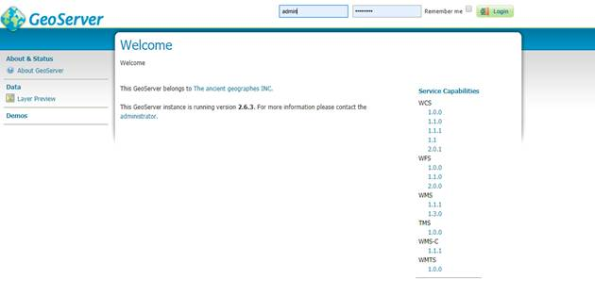

Figure 22 : Sample Configuration Log in Screen

**Step 2: The Welcome Screen**

Figure 23: Sample Configuration Welcome Screen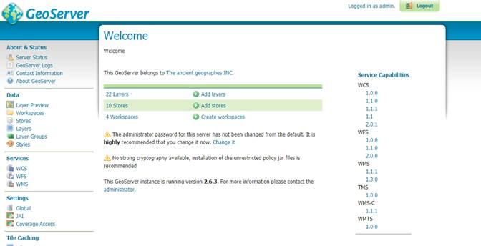

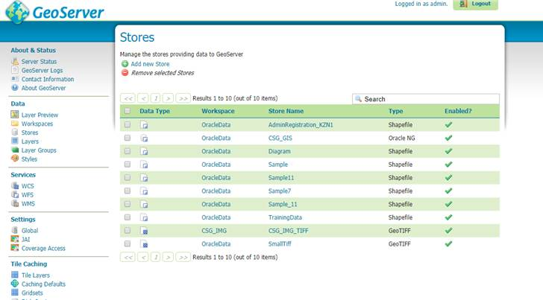**Step 3: The Data Menu**

Figure 24:Sample Configuration Data Menu Screen

**Step 4: Add New Data Menu**

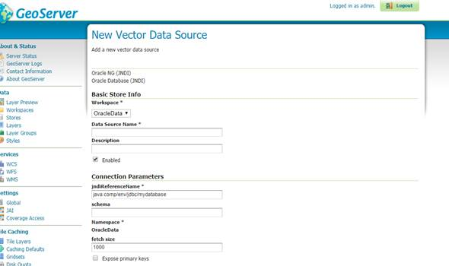

Figure 25:Sample Configuration Add New Data Menu

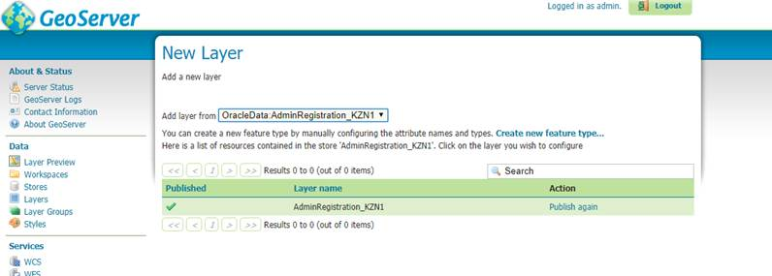**Step 5: View Published Layer**

Figure 26:Sample Configuration View Published Layer

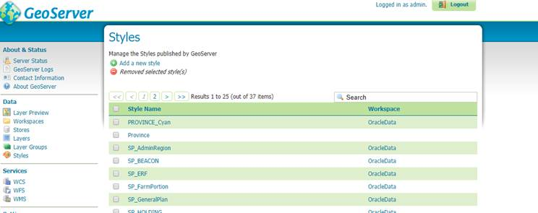**Step 6: Layer Styles**

Figure 27:Sample Configuration Layer Styles

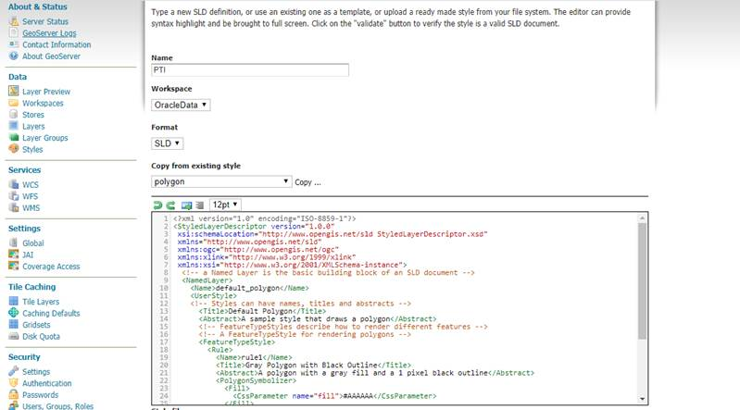**Step 7: Add New Layer Styles**

Figure 28:Sample Configuration Add New Layer Styles

**Step 7: Preview of Layers click on Layers Preview in Data Menu: -**

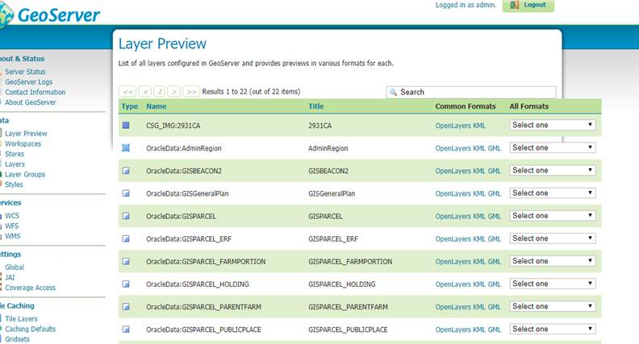

Figure 29:Sample Configuration Preview Layers in Data Menu

# Integration

1. System integration is defined as the process of bringing together the component sub-systems into one system and ensuring that the subsystems function together. Below are the 3 critical subsystems that will be integrated with the Spatial Module:
2. Web Portal
3. User Access Module
4. Information Management Module (IM)
5. The subsystems mentioned above will be seamlessly integrated such that services shall be running in between them. Horizontal and   online integration shall be used to achieve the communication between these systems listed above. The integration envisaged shall be bidirectional in nature. The following table enlists the various events that will be propagated through this integration.

|  |  |  |  |
| --- | --- | --- | --- |
| Event Name | Source | Destination | Description |
| USER_INFO | User Access Management (UAM) | Web Portal  IM  Spatial Viewer | The event that is triggered to initiate get user information |
| SPATIAL_INFO | Spatial Viewer | Information Management | The events that will be triggered when a user interacts with the Spatial Viewer |
| SPATIAL_SINGLE | Spatial Viewer | Information Management  UAM | The events that will be triggered when a user executes/ downloads information from the spatial |
| SPATIAL_BULK | Spatial Viewer | Information Management  UAM | The events that will be triggered when a user executes bulk requests from spatial. |
| PARA_VIEW | Information Management | Spatial Viewer  UAM | The events that will be triggered when a user executes searchers with spatial data from Information Management Module |
| SINGE_REQ | Information Management | Spatial Viewer  UAM | The event triggered from the Information Management Modulefor single requests |
| BULK_REQ | Information Management | UAM  Spatial Viewer | The event triggered from the Information Management Module for bulk requests |

Table 17: Integration Touch Points

1. The typical information that will be sent between the subsystems will be the following :(although these still need to be unpacked on the integration document which is mostly done towards the end of a successful Implementation)
   1. Requestor Information
   2. Request Category
   3. Request Subcategory
   4. Items*
   5. LPI code(s),
   6. Output type,
   7. Layer name,
   8. Province,
2. Munsys Integration still needs to be further unpacked but it does not affect anything on the current release. The envisaged integration at that point can be one of the following:
3. **Option 1**

Oracle data tables that store spatial data will be made available to the Munsys software in a read-only mode.

1. **Option 2**

Data can be exchanged through services between two components

1. **Option 3**

Fully integrated solution with seamless interaction between two systems

This section will be updated based on further interactions with the project team and the technical team of MunSys.

.

# Reports

This section will detail what reports will be generated from Spatial Component. However, it is worth noting that the reports at spatial will be the same as the reports on the Information, User Access, and Web portal. There will be no standalone reports on the Spatial Viewer

1. **Statistical Report:** This is a report that shows all systems statistical data in terms of what data was requested by the users and the count thereof.

The template overleaf is a sample Statistical Report:

All the reports can be exported to the following document types as per the discretion of the user.

* Excel
* PDF



### Sample Statistical Report

**Statistical Report**

**Date:** (01/11/2018-31/11/2018)

**Province:** (All)

**Municipality:** (All)

**Sub Directorate / Unit:** (All)

**Type of Stats:** Request

**Request Category:** (All)

**Task Status:** (All)

|  |  |  |  |  |
| --- | --- | --- | --- | --- |
| Job Description/Category | Province | Municipality | Sub divisional/ Unit | Number of requests |
| Preparation of certificates, Reports to court, Affidavits and Alphabetical Lists | Mpumalanga | All | Information Provision | 10 |
| Maps of the National Series | Mpumalanga | All | Information Provision | 25 |
| Digital Cadastral and Related Information | Mpumalanga | Emakhazeni Municipality | Information Provision | 2 |
| General plan list | Mpumalanga | All | Information Provision | 40 |
| Coordinate list | Eastern Cape | All | Spatial | 20 |
| Diagrams | Western Cape | All | Spatial | 56 |
| Arial Map | Eastern Cape | Alfred Nzo Municipality | Spatial | 2 |

# System Administration Module

System Administration refers to the upkeep, configuration, and reliable operation of computer systems; especially multi-user systems. The system administrator seeks to ensure that the uptime, performance, resources, and security of the computers they manage meet the needs of the users. To meet these needs, a system administrator may acquire, install, or upgrade computer components and software; provide routine automation; maintain security policies; troubleshoot; train or supervise staff; or offer technical support for projects. This section below will list the components of the system that the system Administrator should be able to configure and update. This will be done on the Information Management Module administration and not on the Spatial Component

Please note in the table below configure includes the following;

* 1. Create
  2. Edit
  3. Delete (soft delete)

|  |  |  |
| --- | --- | --- |
| **Process(s)** | **Function** | **Process** |
| Single Request | Configure Number of Features | 1. Select the Category 2. Select Subcategory 3. Set Maximum Feature Count 4. Save |
| Bulk Request | Configure email content – e.g. Share View | 1. Access the email configuration 2. Select the process node 3. Enter the email Content 4. Save |

# Annexures

## 

Following are the attributes of the projected coordinate system (LO/WG):

|  |  |
| --- | --- |
| Unit | Metre |
| Geodetic CRS | . ***Hartebeesthoek94*** *–* ***LatLon*** |
| Datum | ***Hartebeesthoek94*** *Datum* |
| Ellipsoid | WGS 84 |
| Prime meridian | Greenwich |

## 

## PROJ.4 Definitions used in this project

|  |  |
| --- | --- |
| Band | Definition |
| Hartebeesthoek94 */*Lo15 | var LO15 = new ProjectedCoordinateSystem('LO15', 'EPSG:2046', '+proj=tmerc +lat_0=0 +lon_0=15 +k=1 +x_0=0 +y_0=0 +axis=wsu +ellps=WGS84 +towgs84=0,0,0,0,0,0,0 +units=m +no_defs'); |
| Hartebeesthoek94 / Lo  17 | var LO17 = new ProjectedCoordinateSystem('LO17', 'EPSG:2047', '+proj=tmerc +lat_0=0 +lon_0=17 +k=1 +x_0=0 +y_0=0 +axis=wsu +ellps=WGS84 +towgs84=0,0,0,0,0,0,0 +units=m +no_defs'); |
| Hartebeesthoek94 / Lo  19 | var LO19 = new ProjectedCoordinateSystem('LO19', 'EPSG:2048', '+proj=tmerc +lat_0=0 +lon_0=19 +k=1 +x_0=0 +y_0=0 +axis=wsu +ellps=WGS84 +towgs84=0,0,0,0,0,0,0 +units=m +no_defs'); |
| Hartebeesthoek94 / Lo  21 | var LO21 = new ProjectedCoordinateSystem('LO21', 'EPSG:2049', '+proj=tmerc +lat_0=0 +lon_0=21 +k=1 +x_0=0 +y_0=0 +axis=wsu +ellps=WGS84 +towgs84=0,0,0,0,0,0,0 +units=m +no_defs'); |
| Hartebeesthoek94 / Lo  23 | var LO23 = new ProjectedCoordinateSystem('LO23', 'EPSG:2050', '+proj=tmerc +lat_0=0 +lon_0=23 +k=1 +x_0=0 +y_0=0 +axis=wsu +ellps=WGS84 +towgs84=0,0,0,0,0,0,0 +units=m +no_defs'); |
| Hartebeesthoek94 / Lo  25 | var LO25 = new ProjectedCoordinateSystem('LO25', 'EPSG:2051', '+proj=tmerc +lat_0=0 +lon_0=25 +k=1 +x_0=0 +y_0=0 +axis=wsu +ellps=WGS84 +towgs84=0,0,0,0,0,0,0 +units=m +no_defs'); |
| Hartebeesthoek94 / Lo  27 | var LO27 = new ProjectedCoordinateSystem('LO27', 'EPSG:2052', '+proj=tmerc +lat_0=0 +lon_0=27 +k=1 +x_0=0 +y_0=0 +axis=wsu +ellps=WGS84 +towgs84=0,0,0,0,0,0,0 +units=m +no_defs'); |
| Hartebeesthoek94 / Lo  29 | var LO29 = new ProjectedCoordinateSystem('LO29', 'EPSG:2053', '+proj=tmerc +lat_0=0 +lon_0=29 +k=1 +x_0=0 +y_0=0 +axis=wsu +ellps=WGS84 +towgs84=0,0,0,0,0,0,0 +units=m +no_defs'); |
| Hartebeesthoek94 / Lo  31 | var LO31 = new ProjectedCoordinateSystem('LO31', 'EPSG:2054', '+proj=tmerc +lat_0=0 +lon_0=31 +k=1 +x_0=0 +y_0=0 +axis=wsu +ellps=WGS84 +towgs84=0,0,0,0,0,0,0 +units=m +no_defs'); |
| Hartebeesthoek94 / Lo  33 | var LO33 = new ProjectedCoordinateSystem('LO33', 'EPSG:2055', '+proj=tmerc +lat_0=0 +lon_0=33 +k=1 +x_0=0 +y_0=0 +axis=wsu +ellps=WGS84 +towgs84=0,0,0,0,0,0,0 +units=m +no_defs'); |

## Attributes and defining parameters of Projected Coordinate Reference Systems

The attributes and defining parameters for the projected coordinate reference systems (PCRS), referenced to the European Petroleum Survey Group (EPSG) Geodetic Parameter Registry, are as follows. Proj4 is the open-source library utilized for this project. The references below are included in this document to confirm that there are no material differences between Proj4 and the EPSG Geodetic Parameter Registry.

|  |  |  |  |  |  |  |  |  |  |  |
| --- | --- | --- | --- | --- | --- | --- | --- | --- | --- | --- |
| *PCRS Name* | **Hartebeesthoek94 /**  **/ Lo15** | | | | | | | | | |
| *Identifier* | EPSG::2046 | | | | | | | | | |
| *Aliases* | Alias | | | | Naming System | | | Remarks | | |
| New S African CS zone 15 | | | | EPSG alias | | |  | | |
| *Scope* | Large and medium scale topographic mapping, cadastral and engineering survey. | | | | | | | | | |
| *Remarks* |  | | | | | | | | | |
| *Area Description* | Namibia - Walvis Bay. | | | | | | | | | |
| *Derived From* | *Base CRS Name* | Projected coordinate system | | | | | | | | |
| *Base CRS Type* | geographic 2D | | | | | | | | |
| *Geodetic Datum* | Projected coordinate system | | | | | | | | |
| *Prime Meridian* | Greenwich | | | | 0°E | | degree | |
| *Ellipsoid* | WGS 84 — Alias(es): [WGS84] | | | | | | | |
| *Semi-Major Axis (a)* | | 6378137 | | | | metre | |
| *Inverse flattening* | | 298.257223563 | | | | unity | |
| *Map Projection* | *Name* | South African Survey Grid zone 15 — Alias(es): [S. African Grid zone 15, Lo15] | | | | | | | | |
| *Operation Method* | Transverse Mercator (South Orientated) | | | | | | | | |
| *Is the operation reversible?* | | | Yes | | | | | |
| *Conversion Parameters* | Parameter Name | | Parameter Value  or Parameter File | | Unit of Measure | | | | Sign Reversal |
| Latitude of natural origin | | 0°N | | degree | | | | No |
| Longitude of natural origin | | 15°E | | degree | | | | No |
| Scale factor at natural origin | | 1 | | unity | | | | No |
| False easting | | 0 | | metre | | | | No |
| False northing | | 0 | | metre | | | | No |
| *Coordinate Axes* | Order | Axis Name | | Abbrev. | | Unit of Measure | | | | Orientation |
| 1 | Westing | | Y | | metre | | | | west |
| 2 | Southing | | X | | metre | | | | south |

|  |  |  |  |  |  |  |  |  |  |  |
| --- | --- | --- | --- | --- | --- | --- | --- | --- | --- | --- |
| *PCRS Name* | **Hartebeesthoek94 /**  **Lo17** | | | | | | | | | |
| *Identifier* | EPSG::2047 | | | | | | | | | |
| *Aliases* | Alias | | | | Naming System | | | Remarks | | |
| New S African CS zone 17 | | | | EPSG alias | | |  | | |
| *Scope* | Large and medium scale topographic mapping, cadastral and engineering survey. | | | | | | | | | |
| *Remarks* |  | | | | | | | | | |
| *Area Description* | South Africa - onshore west of 18°E. | | | | | | | | | |
| *Derived From* | *Base CRS Name* | Projected coordinate system | | | | | | | | |
| *Base CRS Type* | geographic 2D | | | | | | | | |
| *Geodetic Datum* | Projected coordinate system | | | | | | | | |
| *Prime Meridian* | Greenwich | | | | 0°E | | degree | |
| *Ellipsoid* | WGS 84 — Alias(es): [WGS84] | | | | | | | |
| *Semi-Major Axis (a)* | | 6378137 | | | | metre | |
| *Inverse flattening* | | 298.257223563 | | | | unity | |
| *Map Projection* | *Name* | South African Survey Grid zone 17 — Alias(es): [S. African Grid zone 17, Lo17] | | | | | | | | |
| *Operation Method* | Transverse Mercator (South Orientated) | | | | | | | | |
| *Is the operation reversible?* | | | Yes | | | | | |
| *Conversion Parameters* | Parameter Name | | Parameter Value  or Parameter File | | Unit of Measure | | | | Sign Reversal |
| Latitude of natural origin | | 0°N | | degree | | | | No |
| Longitude of natural origin | | 17°E | | degree | | | | No |
| Scale factor at natural origin | | 1 | | unity | | | | No |
| False easting | | 0 | | metre | | | | No |
| False northing | | 0 | | metre | | | | No |
| *Coordinate Axes* | Order | Axis Name | | Abbrev. | | Unit of Measure | | | | Orientation |
| 1 | Westing | | Y | | metre | | | | west |
| 2 | Southing | | X | | metre | | | | south |

|  |  |  |  |  |  |  |  |  |  |  |
| --- | --- | --- | --- | --- | --- | --- | --- | --- | --- | --- |
| *PCRS Name* | **Hartebeesthoek94 /**  **/ Lo19** | | | | | | | | | |
| *Identifier* | EPSG::2048 | | | | | | | | | |
| *Aliases* | Alias | | | | Naming System | | | Remarks | | |
| New S African CS zone 19 | | | | EPSG alias | | |  | | |
| *Scope* | Large and medium scale topographic mapping, cadastral and engineering survey. | | | | | | | | | |
| *Remarks* |  | | | | | | | | | |
| *Area Description* | South Africa - onshore between 18°E and 20°E. | | | | | | | | | |
| *Derived From* | *Base CRS Name* | Projected coordinate system | | | | | | | | |
| *Base CRS Type* | geographic 2D | | | | | | | | |
| *Geodetic Datum* | Projected coordinate system | | | | | | | | |
| *Prime Meridian* | Greenwich | | | | 0°E | | degree | |
| *Ellipsoid* | WGS 84 — Alias(es): [WGS84] | | | | | | | |
| *Semi-Major Axis (a)* | | 6378137 | | | | metre | |
| *Inverse flattening* | | 298.257223563 | | | | unity | |
| *Map Projection* | *Name* | South African Survey Grid zone 19 — Alias(es): [S. African Grid zone 19, Lo19] | | | | | | | | |
| *Operation Method* | Transverse Mercator (South Orientated) | | | | | | | | |
| *Is the operation reversible?* | | | Yes | | | | | |
| *Conversion Parameters* | Parameter Name | | Parameter Value  or Parameter File | | Unit of Measure | | | | Sign Reversal |
| Latitude of natural origin | | 0°N | | degree | | | | No |
| Longitude of natural origin | | 19°E | | degree | | | | No |
| Scale factor at natural origin | | 1 | | unity | | | | No |
| False easting | | 0 | | metre | | | | No |
| False northing | | 0 | | metre | | | | No |
| *Coordinate Axes* | Order | Axis Name | | Abbrev. | | Unit of Measure | | | | Orientation |
| 1 | Westing | | Y | | metre | | | | west |
| 2 | Southing | | X | | metre | | | | south |

|  |  |  |  |  |  |  |  |  |  |  |
| --- | --- | --- | --- | --- | --- | --- | --- | --- | --- | --- |
| *PCRS Name* | **Hartebeesthoek94 /**  **/ Lo21** | | | | | | | | | |
| *Identifier* | EPSG::2049 | | | | | | | | | |
| *Aliases* | Alias | | | | Naming System | | | Remarks | | |
| New S African CS zone 21 | | | | EPSG alias | | |  | | |
| *Scope* | Large and medium scale topographic mapping, cadastral and engineering survey. | | | | | | | | | |
| *Remarks* |  | | | | | | | | | |
| *Area Description* | South Africa - onshore between 20°E and 22°E. | | | | | | | | | |
| *Derived From* | *Base CRS Name* | Projected coordinate system | | | | | | | | |
| *Base CRS Type* | geographic 2D | | | | | | | | |
| *Geodetic Datum* | Projected coordinate system | | | | | | | | |
| *Prime Meridian* | Greenwich | | | | 0°E | | degree | |
| *Ellipsoid* | WGS 84 — Alias(es): [WGS84] | | | | | | | |
| *Semi-Major Axis (a)* | | 6378137 | | | | metre | |
| *Inverse flattening* | | 298.257223563 | | | | unity | |
| *Map Projection* | *Name* | South African Survey Grid zone 21 — Alias(es): [S. African Grid zone 21, Lo21] | | | | | | | | |
| *Operation Method* | Transverse Mercator (South Orientated) | | | | | | | | |
| *Is the operation reversible?* | | | Yes | | | | | |
| *Conversion Parameters* | Parameter Name | | Parameter Value  or Parameter File | | Unit of Measure | | | | Sign Reversal |
| Latitude of natural origin | | 0°N | | degree | | | | No |
| Longitude of natural origin | | 21°E | | degree | | | | No |
| Scale factor at natural origin | | 1 | | unity | | | | No |
| False easting | | 0 | | metre | | | | No |
| False northing | | 0 | | metre | | | | No |
| *Coordinate Axes* | Order | Axis Name | | Abbrev. | | Unit of Measure | | | | Orientation |
| 1 | Westing | | Y | | metre | | | | west |
| 2 | Southing | | X | | metre | | | | south |

|  |  |  |  |  |  |  |  |  |  |  |
| --- | --- | --- | --- | --- | --- | --- | --- | --- | --- | --- |
| *PCRS Name* | **Hartebeesthoek94 /**  **/ Lo23** | | | | | | | | | |
| *Identifier* | EPSG::2050 | | | | | | | | | |
| *Aliases* | Alias | | | | Naming System | | | Remarks | | |
| New S African CS zone 23 | | | | EPSG alias | | |  | | |
| *Scope* | Large and medium scale topographic mapping, cadastral and engineering survey. | | | | | | | | | |
| *Remarks* |  | | | | | | | | | |
| *Area Description* | South Africa - onshore between 22°E and 24°E. | | | | | | | | | |
| *Derived From* | *Base CRS Name* | Projected coordinate system | | | | | | | | |
| *Base CRS Type* | geographic 2D | | | | | | | | |
| *Geodetic Datum* | Projected coordinate system | | | | | | | | |
| *Prime Meridian* | Greenwich | | | | 0°E | | degree | |
| *Ellipsoid* | WGS 84 — Alias(es): [WGS84] | | | | | | | |
| *Semi-Major Axis (a)* | | 6378137 | | | | metre | |
| *Inverse flattening* | | 298.257223563 | | | | unity | |
| *Map Projection* | *Name* | South African Survey Grid zone 23 — Alias(es): [S. African Grid zone 23, Lo23] | | | | | | | | |
| *Operation Method* | Transverse Mercator (South Orientated) | | | | | | | | |
| *Is the operation reversible?* | | | Yes | | | | | |
| *Conversion Parameters* | Parameter Name | | Parameter Value  or Parameter File | | Unit of Measure | | | | Sign Reversal |
| Latitude of natural origin | | 0°N | | degree | | | | No |
| Longitude of natural origin | | 23°E | | degree | | | | No |
| Scale factor at natural origin | | 1 | | unity | | | | No |
| False easting | | 0 | | metre | | | | No |
| False northing | | 0 | | metre | | | | No |
| *Coordinate Axes* | Order | Axis Name | | Abbrev. | | Unit of Measure | | | | Orientation |
| 1 | Westing | | Y | | metre | | | | west |
| 2 | Southing | | X | | metre | | | | south |

|  |  |  |  |  |  |  |  |  |  |  |
| --- | --- | --- | --- | --- | --- | --- | --- | --- | --- | --- |
| *PCRS Name* | **Hartebeesthoek94 /**  **Lo25** | | | | | | | | | |
| *Identifier* | EPSG::2051 | | | | | | | | | |
| *Aliases* | Alias | | | | Naming System | | | Remarks | | |
| New S African CS zone 25 | | | | EPSG alias | | |  | | |
| *Scope* | Large and medium scale topographic mapping, cadastral and engineering survey. | | | | | | | | | |
| *Remarks* |  | | | | | | | | | |
| *Area Description* | South Africa - onshore between 24°E and 26°E. | | | | | | | | | |
| *Derived From* | *Base CRS Name* | Projected coordinate system | | | | | | | | |
| *Base CRS Type* | geographic 2D | | | | | | | | |
| *Geodetic Datum* | Projected coordinate system | | | | | | | | |
| *Prime Meridian* | Greenwich | | | | 0°E | | degree | |
| *Ellipsoid* | WGS 84 — Alias(es): [WGS84] | | | | | | | |
| *Semi-Major Axis (a)* | | 6378137 | | | | metre | |
| *Inverse flattening* | | 298.257223563 | | | | unity | |
| *Map Projection* | *Name* | South African Survey Grid zone 25 — Alias(es): [S. African Grid zone 25, Lo25] | | | | | | | | |
| *Operation Method* | Transverse Mercator (South Orientated) | | | | | | | | |
| *Is the operation reversible?* | | | Yes | | | | | |
| *Conversion Parameters* | Parameter Name | | Parameter Value  or Parameter File | | Unit of Measure | | | | Sign Reversal |
| Latitude of natural origin | | 0°N | | degree | | | | No |
| Longitude of natural origin | | 25°E | | degree | | | | No |
| Scale factor at natural origin | | 1 | | unity | | | | No |
| False easting | | 0 | | metre | | | | No |
| False northing | | 0 | | metre | | | | No |
| *Coordinate Axes* | Order | Axis Name | | Abbrev. | | Unit of Measure | | | | Orientation |
| 1 | Westing | | Y | | metre | | | | west |
| 2 | Southing | | X | | metre | | | | south |

|  |  |  |  |  |  |  |  |  |  |  |
| --- | --- | --- | --- | --- | --- | --- | --- | --- | --- | --- |
| *PCRS Name* | **Hartebeesthoek94 /**  **Lo27** | | | | | | | | | |
| *Identifier* | EPSG::2052 | | | | | | | | | |
| *Aliases* | Alias | | | | Naming System | | | Remarks | | |
| New S African CS zone 27 | | | | EPSG alias | | |  | | |
| *Scope* | Large and medium scale topographic mapping, cadastral and engineering survey. | | | | | | | | | |
| *Remarks* |  | | | | | | | | | |
| *Area Description* | South Africa - onshore between 26°E and 28°E. | | | | | | | | | |
| *Derived From* | *Base CRS Name* | Projected coordinate system | | | | | | | | |
| *Base CRS Type* | geographic 2D | | | | | | | | |
| *Geodetic Datum* | Projected coordinate system | | | | | | | | |
| *Prime Meridian* | Greenwich | | | | 0°E | | degree | |
| *Ellipsoid* | WGS 84 — Alias(es): [WGS84] | | | | | | | |
| *Semi-Major Axis (a)* | | 6378137 | | | | metre | |
| *Inverse flattening* | | 298.257223563 | | | | unity | |
| *Map Projection* | *Name* | South African Survey Grid zone 27 — Alias(es): [S. African Grid zone 27, Lo27] | | | | | | | | |
| *Operation Method* | Transverse Mercator (South Orientated) | | | | | | | | |
| *Is the operation reversible?* | | | Yes | | | | | |
| *Conversion Parameters* | Parameter Name | | Parameter Value  or Parameter File | | Unit of Measure | | | | Sign Reversal |
| Latitude of natural origin | | 0°N | | degree | | | | No |
| Longitude of natural origin | | 27°E | | degree | | | | No |
| Scale factor at natural origin | | 1 | | unity | | | | No |
| False easting | | 0 | | metre | | | | No |
| False northing | | 0 | | metre | | | | No |
| *Coordinate Axes* | Order | Axis Name | | Abbrev. | | Unit of Measure | | | | Orientation |
| 1 | Westing | | Y | | metre | | | | west |
| 2 | Southing | | X | | metre | | | | south |

|  |  |  |  |  |  |  |  |  |  |  |
| --- | --- | --- | --- | --- | --- | --- | --- | --- | --- | --- |
| *PCRS Name* | **Hartebeesthoek94 /**  **Lo29** | | | | | | | | | |
| *Identifier* | EPSG::2053 | | | | | | | | | |
| *Aliases* | Alias | | | | Naming System | | | Remarks | | |
| New S African CS zone 29 | | | | EPSG alias | | |  | | |
| *Scope* | Large and medium scale topographic mapping, cadastral and engineering survey. | | | | | | | | | |
| *Remarks* |  | | | | | | | | | |
| *Area Description* | South Africa - onshore between 28°E and 30°E. | | | | | | | | | |
| *Derived From* | *Base CRS Name* | Projected coordinate system | | | | | | | | |
| *Base CRS Type* | geographic 2D | | | | | | | | |
| *Geodetic Datum* | Projected coordinate system | | | | | | | | |
| *Prime Meridian* | Greenwich | | | | 0°E | | degree | |
| *Ellipsoid* | WGS 84 — Alias(es): [WGS84] | | | | | | | |
| *Semi-Major Axis (a)* | | 6378137 | | | | metre | |
| *Inverse flattening* | | 298.257223563 | | | | unity | |
| *Map Projection* | *Name* | South African Survey Grid zone 29 — Alias(es): [S. African Grid zone 29, Lo29] | | | | | | | | |
| *Operation Method* | Transverse Mercator (South Orientated) | | | | | | | | |
| *Is the operation reversible?* | | | Yes | | | | | |
| *Conversion Parameters* | Parameter Name | | Parameter Value  or Parameter File | | Unit of Measure | | | | Sign Reversal |
| Latitude of natural origin | | 0°N | | degree | | | | No |
| Longitude of natural origin | | 29°E | | degree | | | | No |
| Scale factor at natural origin | | 1 | | unity | | | | No |
| False easting | | 0 | | metre | | | | No |
| False northing | | 0 | | metre | | | | No |
| *Coordinate Axes* | Order | Axis Name | | Abbrev. | | Unit of Measure | | | | Orientation |
| 1 | Westing | | Y | | metre | | | | west |
| 2 | Southing | | X | | metre | | | | south |

|  |  |  |  |  |  |  |  |  |  |  |
| --- | --- | --- | --- | --- | --- | --- | --- | --- | --- | --- |
| *PCRS Name* | **Hartebeesthoek94 /**  **Lo31** | | | | | | | | | |
| *Identifier* | EPSG::2054 | | | | | | | | | |
| *Aliases* | Alias | | | | Naming System | | | Remarks | | |
| New S African CS zone 31 | | | | EPSG alias | | |  | | |
| *Scope* | Large and medium scale topographic mapping, cadastral and engineering survey. | | | | | | | | | |
| *Remarks* |  | | | | | | | | | |
| *Area Description* | South Africa - onshore between 30°E and 32°E. | | | | | | | | | |
| *Derived From* | *Base CRS Name* | Projected coordinate system | | | | | | | | |
| *Base CRS Type* | geographic 2D | | | | | | | | |
| *Geodetic Datum* | Projected coordinate system | | | | | | | | |
| *Prime Meridian* | Greenwich | | | | 0°E | | degree | |
| *Ellipsoid* | WGS 84 — Alias(es): [WGS84] | | | | | | | |
| *Semi-Major Axis (a)* | | 6378137 | | | | metre | |
| *Inverse flattening* | | 298.257223563 | | | | unity | |
| *Map Projection* | *Name* | South African Survey Grid zone 31 — Alias(es): [S. African Grid zone 31, Lo31] | | | | | | | | |
| *Operation Method* | Transverse Mercator (South Orientated) | | | | | | | | |
| *Is the operation reversible?* | | | Yes | | | | | |
| *Conversion Parameters* | Parameter Name | | Parameter Value  or Parameter File | | Unit of Measure | | | | Sign Reversal |
| Latitude of natural origin | | 0°N | | degree | | | | No |
| Longitude of natural origin | | 31°E | | degree | | | | No |
| Scale factor at natural origin | | 1 | | unity | | | | No |
| False easting | | 0 | | metre | | | | No |
| False northing | | 0 | | metre | | | | No |
| *Coordinate Axes* | Order | Axis Name | | Abbrev. | | Unit of Measure | | | | Orientation |
| 1 | Westing | | Y | | metre | | | | west |
| 2 | Southing | | X | | metre | | | | south |

|  |  |  |  |  |  |  |  |  |  |  |
| --- | --- | --- | --- | --- | --- | --- | --- | --- | --- | --- |
| *PCRS Name* | **Hartebeesthoek94 /**  **/ Lo33** | | | | | | | | | |
| *Identifier* | EPSG::2055 | | | | | | | | | |
| *Aliases* | Alias | | | | Naming System | | | Remarks | | |
| New S African CS zone 33 | | | | EPSG alias | | |  | | |
| *Scope* | Large and medium scale topographic mapping, cadastral and engineering survey. | | | | | | | | | |
| *Remarks* |  | | | | | | | | | |
| *Area Description* | South Africa - east of 32°E. | | | | | | | | | |
| *Derived From* | *Base CRS Name* | Projected coordinate system | | | | | | | | |
| *Base CRS Type* | geographic 2D | | | | | | | | |
| *Geodetic Datum* | Projected coordinate system | | | | | | | | |
| *Prime Meridian* | Greenwich | | | | 0°E | | degree | |
| *Ellipsoid* | WGS 84 — Alias(es): [WGS84] | | | | | | | |
| *Semi-Major Axis (a)* | | 6378137 | | | | metre | |
| *Inverse flattening* | | 298.257223563 | | | | unity | |
| *Map Projection* | *Name* | South African Survey Grid zone 33 — Alias(es): [S. African Grid zone 29, Lo33] | | | | | | | | |
| *Operation Method* | Transverse Mercator (South Orientated) | | | | | | | | |
| *Is the operation reversible?* | | | Yes | | | | | |
| *Conversion Parameters* | Parameter Name | | Parameter Value  or Parameter File | | Unit of Measure | | | | Sign Reversal |
| Latitude of natural origin | | 0°N | | degree | | | | No |
| Longitude of natural origin | | 33°E | | degree | | | | No |
| Scale factor at natural origin | | 1 | | unity | | | | No |
| False easting | | 0 | | metre | | | | No |
| False northing | | 0 | | metre | | | | No |
| *Coordinate Axes* | Order | Axis Name | | Abbrev. | | Unit of Measure | | | | Orientation |
| 1 | Westing | | Y | | metre | | | | west |
| 2 | Southing | | X | | metre | | | | south |

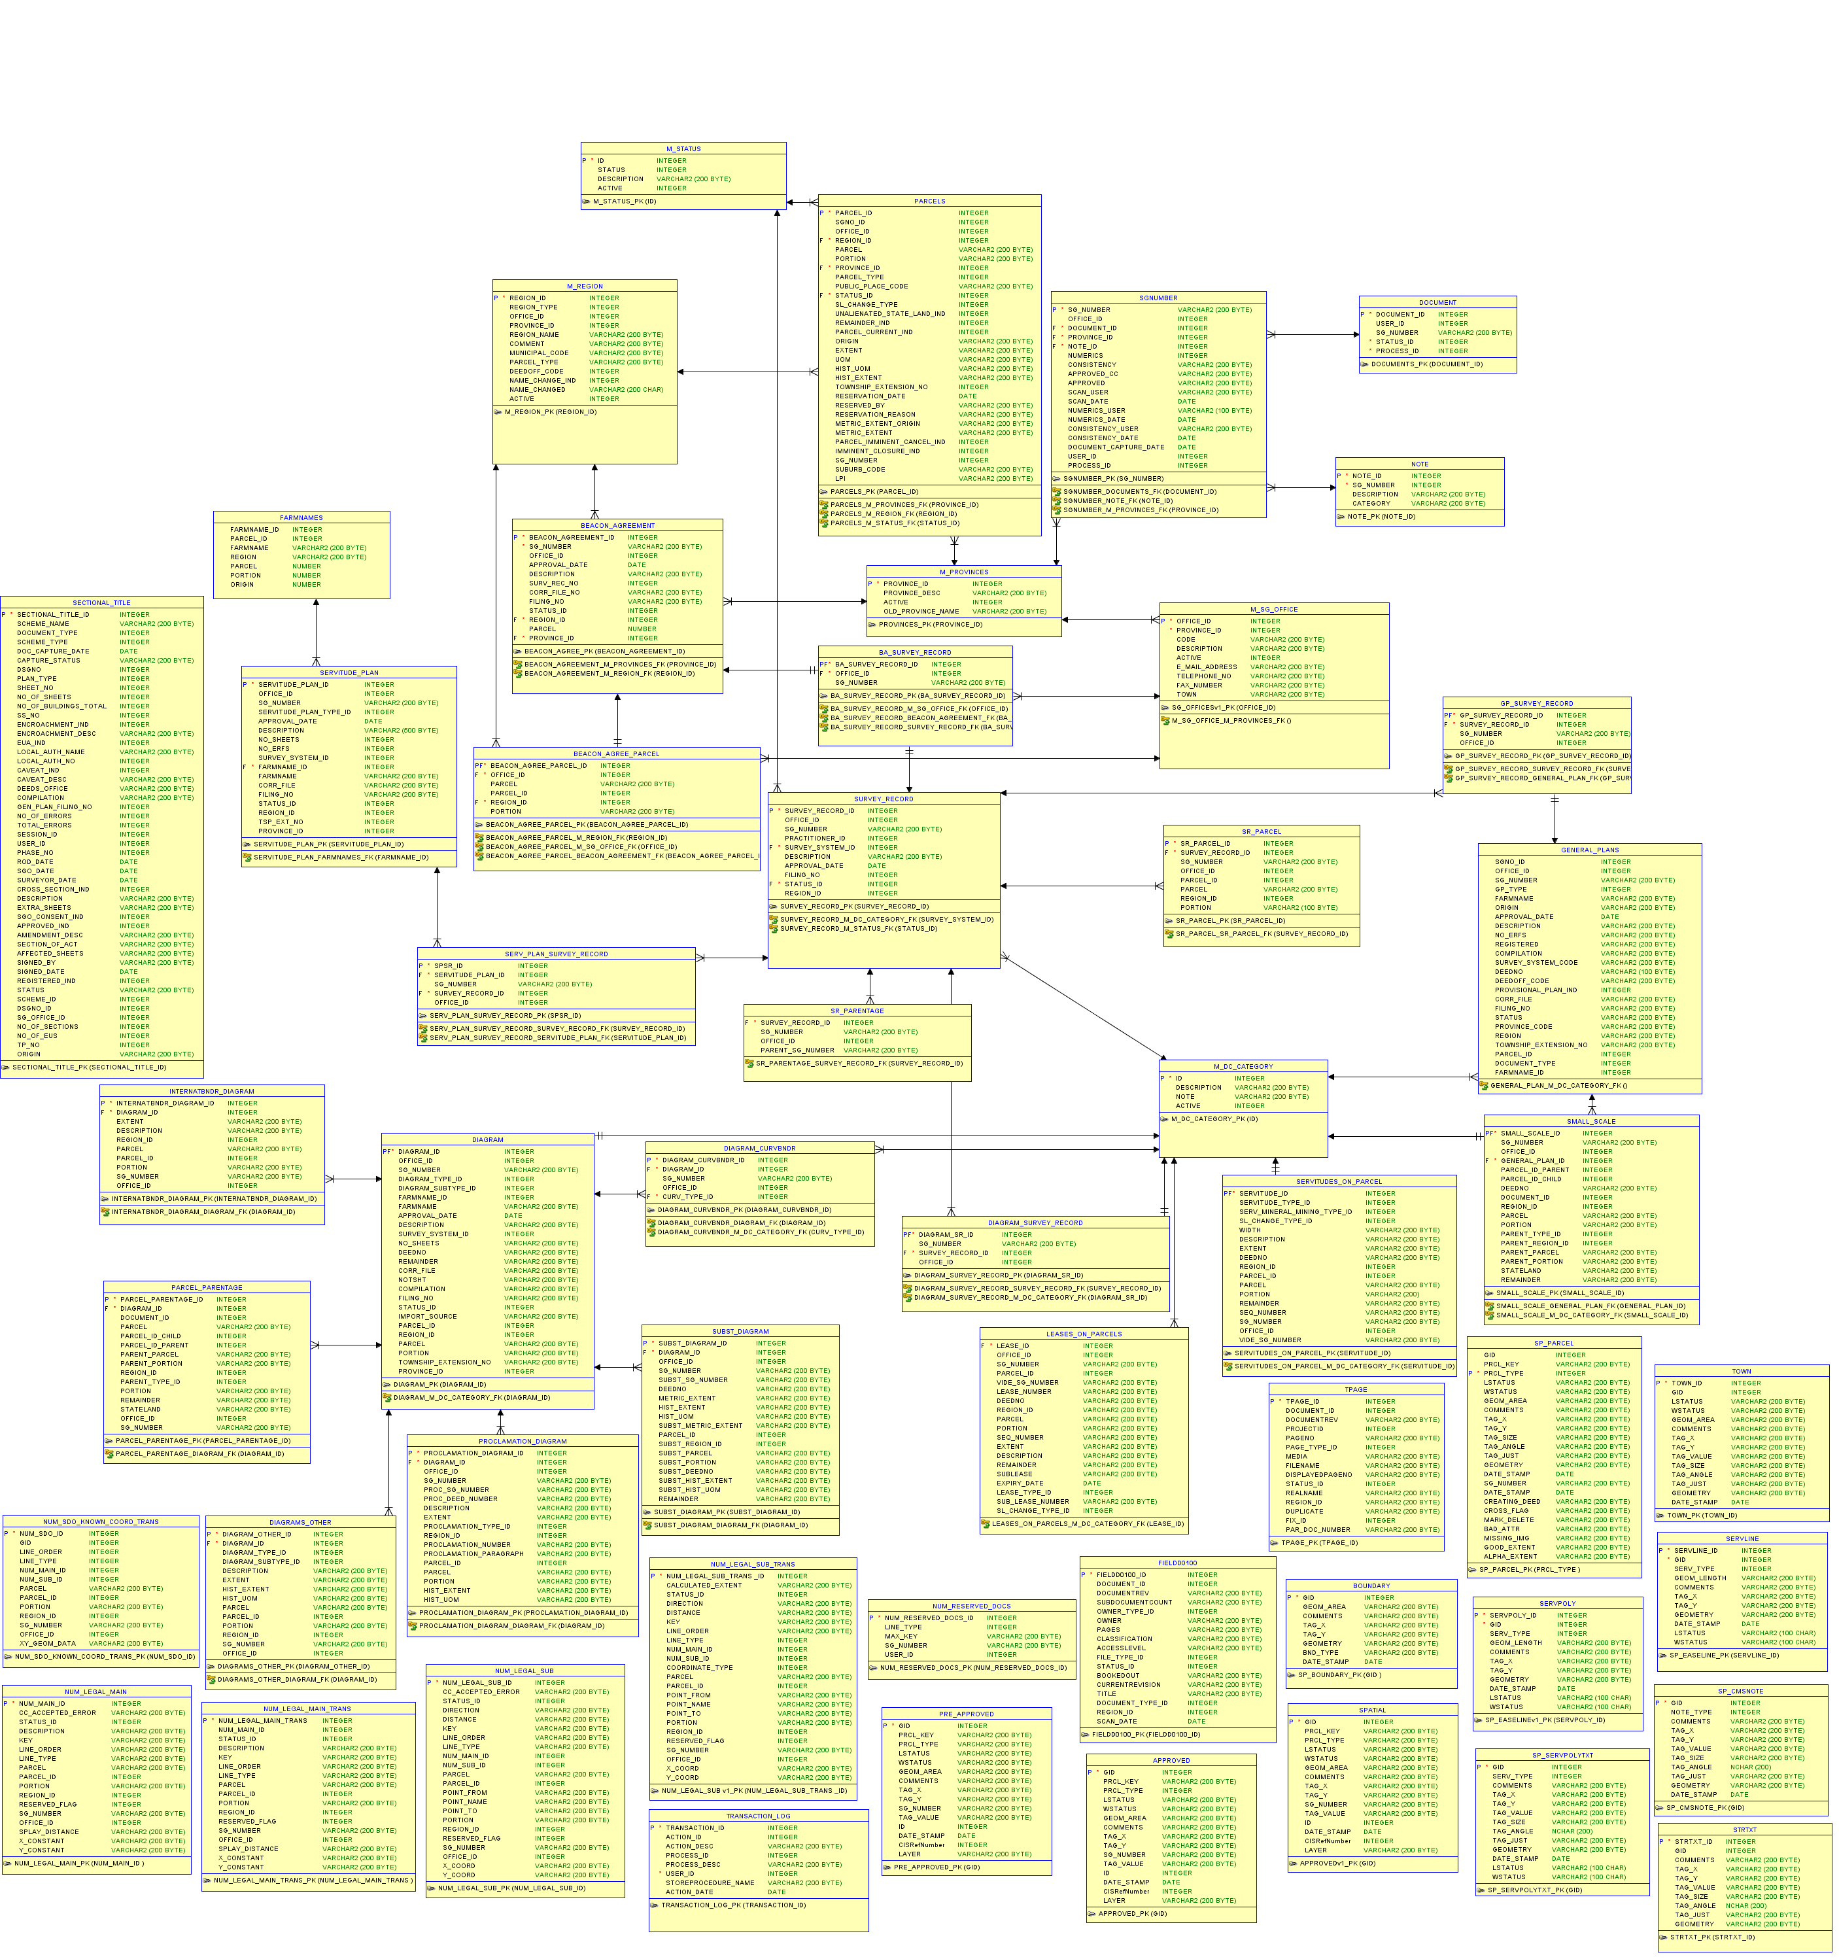

## Conceptual Data Model

## For a detailed Spatial Data Model please refer to the Technical Document

## Product and Services Mapping

## Sample Map Template

(This a department provided template and will be replicated as best as possible utilizing the open source technology stack available to this project)

## 